|  |  |
| --- | --- |
| Lab Guide | Abstract  This document will help you navigate through the lab exercises as part of Masterclass 3  Mark Thomas  Microsoft Defender Masterclass 3 – a partner event created by James Graham |

Contents

Lab Guide Prerequisites 2

Access Microsoft 365 Defender Portal 2

1. Threat Analytics 3

2. Raise Remediation Requests 6

3. Attack Surface Reduction Rules (MEM) 9

4. Attack Surface Reduction Rules (PowerShell) 14

5. Create Attack Surface Reduction Sample Data 15

6. Review Attack Surface Reduction Data 16

6.1 View Attack Surface Reduction Rule Reports 16

6.2 View Attack Surface Reduction Rules in TVM 17

6.3 View Attack Surface Reduction Rules in Advanced Hunting 19

7. Update ASR rule policies to block mode 20

References 21

# Lab Guide Prerequisites

The following prerequisites are required to perform this lab guide:

* A test (non-production) tenant.
* A test (non-production) device onboarded to Microsoft Defender for Endpoint. During the masterclass a test tenant can be provided and data will be pre-populated into the environment.
* Enable Intune Integration via Advanced Features in the Microsoft 365 Defender Portal settings.

<https://docs.microsoft.com/en-us/mem/intune/protect/advanced-threat-protection-configure>

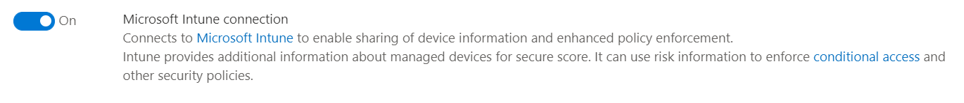

* To target devices with Microsoft Endpoint Manager policies the device must be enrolled into Intune and assigned to a group. For more information on how to enrol a device please see: <https://docs.microsoft.com/en-us/mem/intune/user-help/enroll-windows-10-device>

# Access Microsoft 365 Defender Portal

Login to the Microsoft 365 Defender Portal at <https://security.microsoft.com>

# Threat Analytics

During this section we will review the following items:

* Review a Threat Analytics report
* Review and Run relevant Advanced Hunting queries
* Review recommended mitigations

1. **Review the ‘Ransomware: A pervasive and ongoing threat’ Threat Analytics report**

Navigate to and review the ‘Ransomware: A pervasive and ongoing threat’ Threat Analytics report:

<https://security.microsoft.com/threatanalytics3/05658b6c-dc62-496d-ad3c-c6a795a33c27/overview>

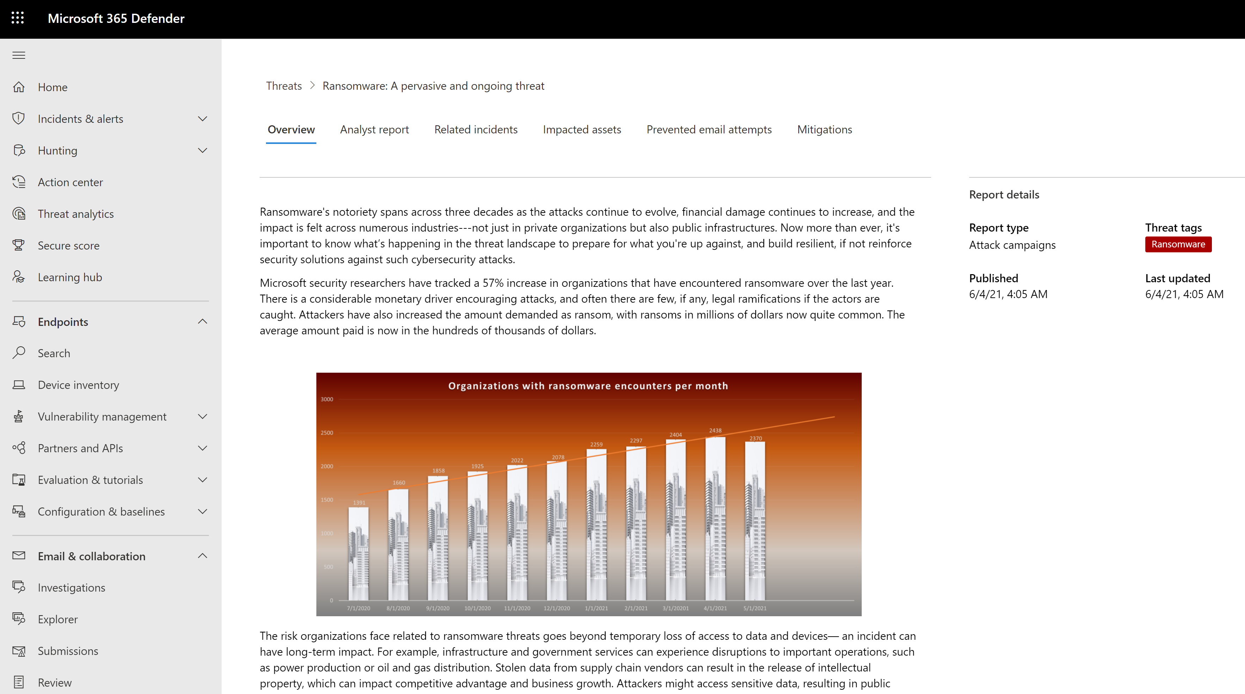

1. **Review example Advanced Hunting queries**

Review the example queries provided in the **Analyst Report** section

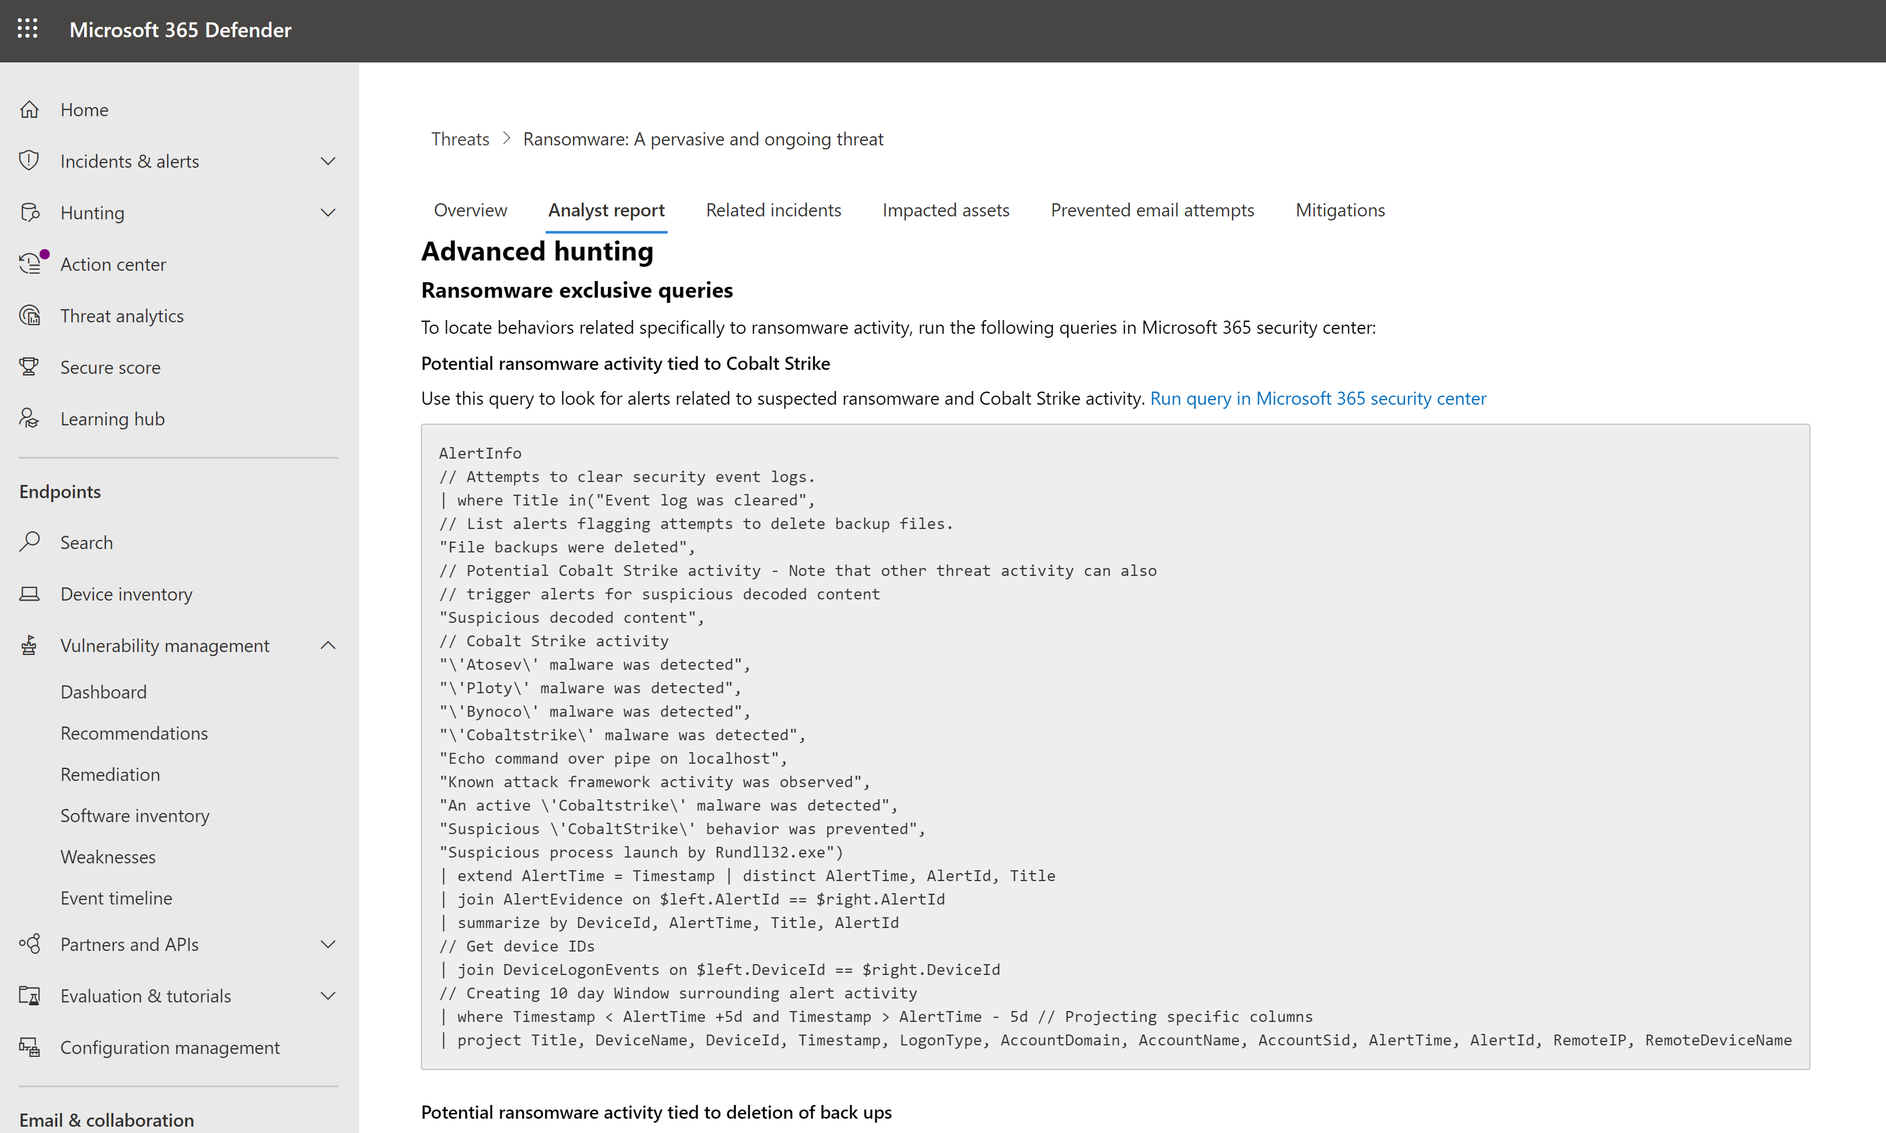

1. **Run example Advanced Hunting queries**

Select ‘**Run query in Microsoft 365 security center**’ to automatically open and run the advanced hunting queries in the query editor:

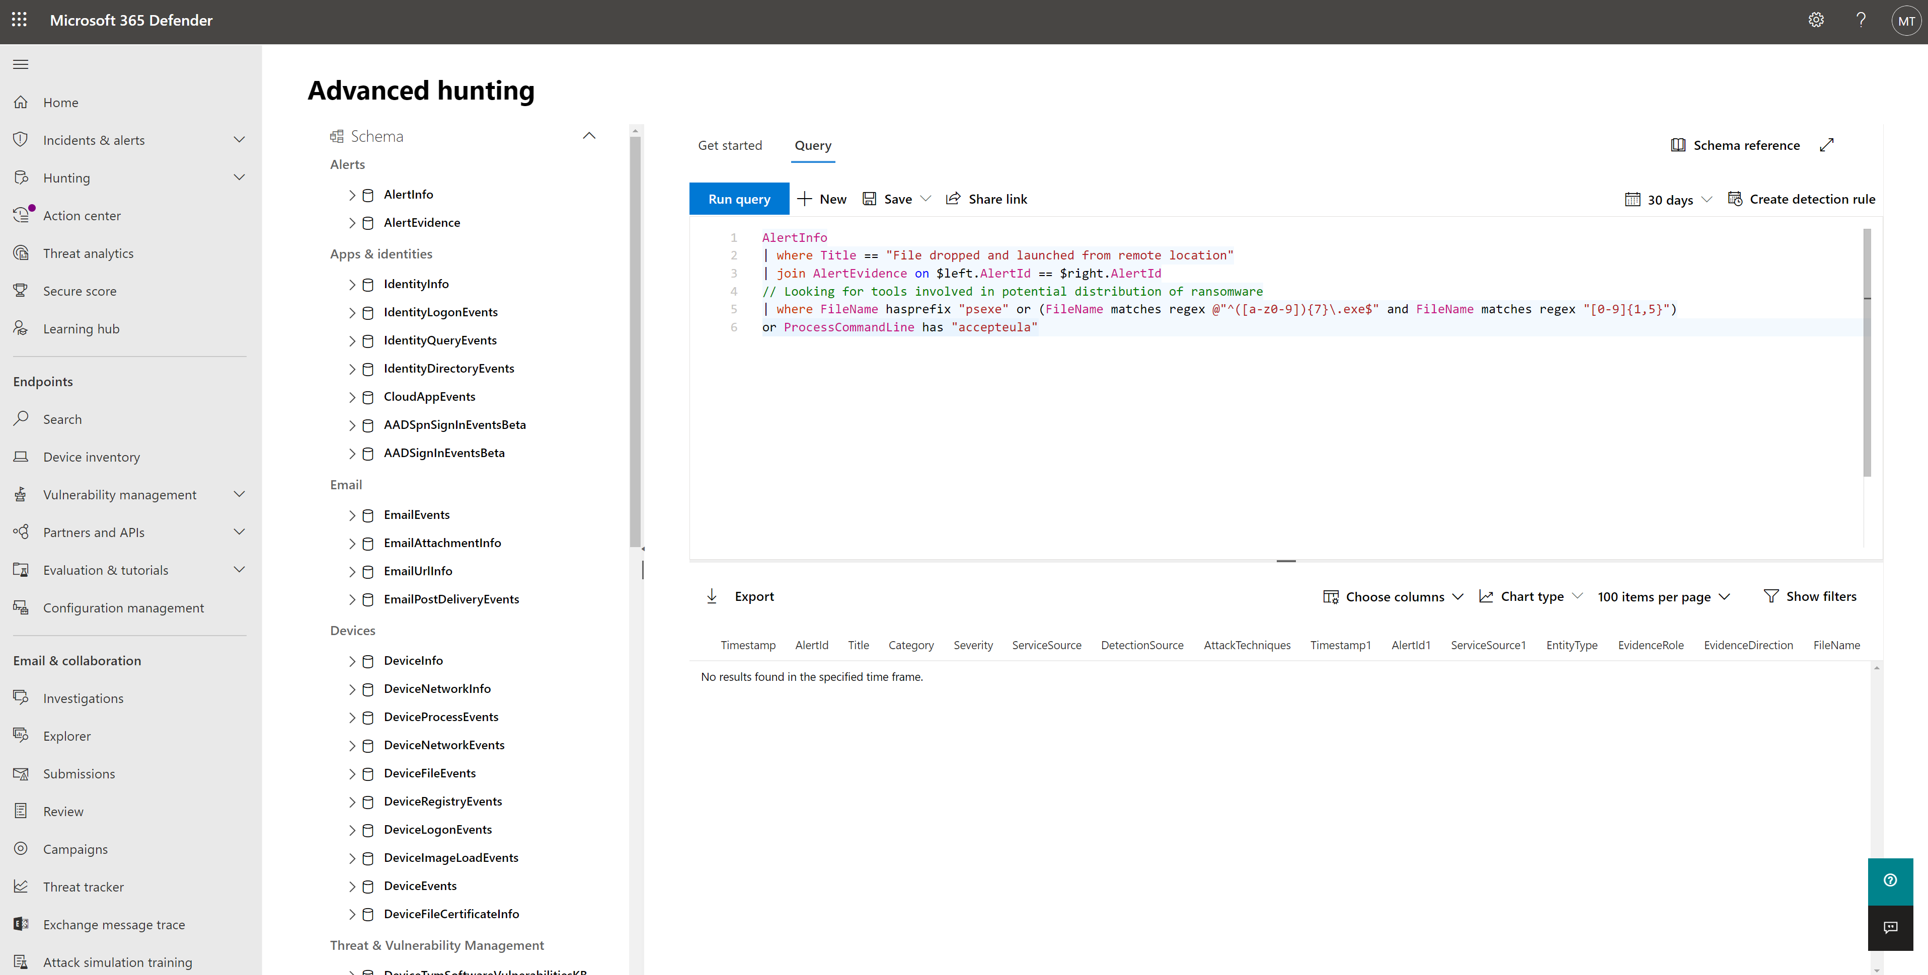

1. **Review the recommended mitigations?**

Within the Threat Analytics report navigate to the **Mitigations** tab to review recommended mitigations and exposed devices.

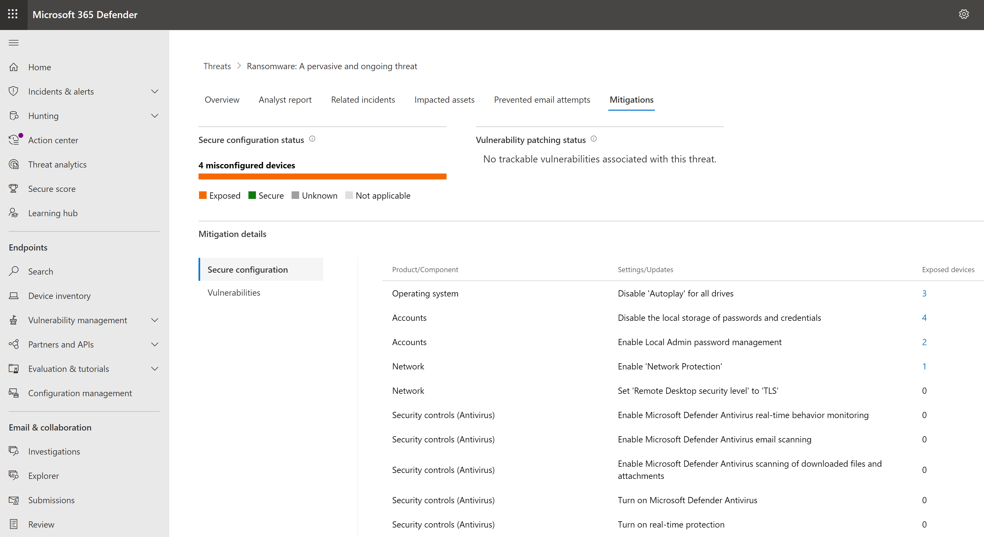

1. **View recommended security remediations**

Click into individual mitigations to see the data on the mitigation and exposed devices

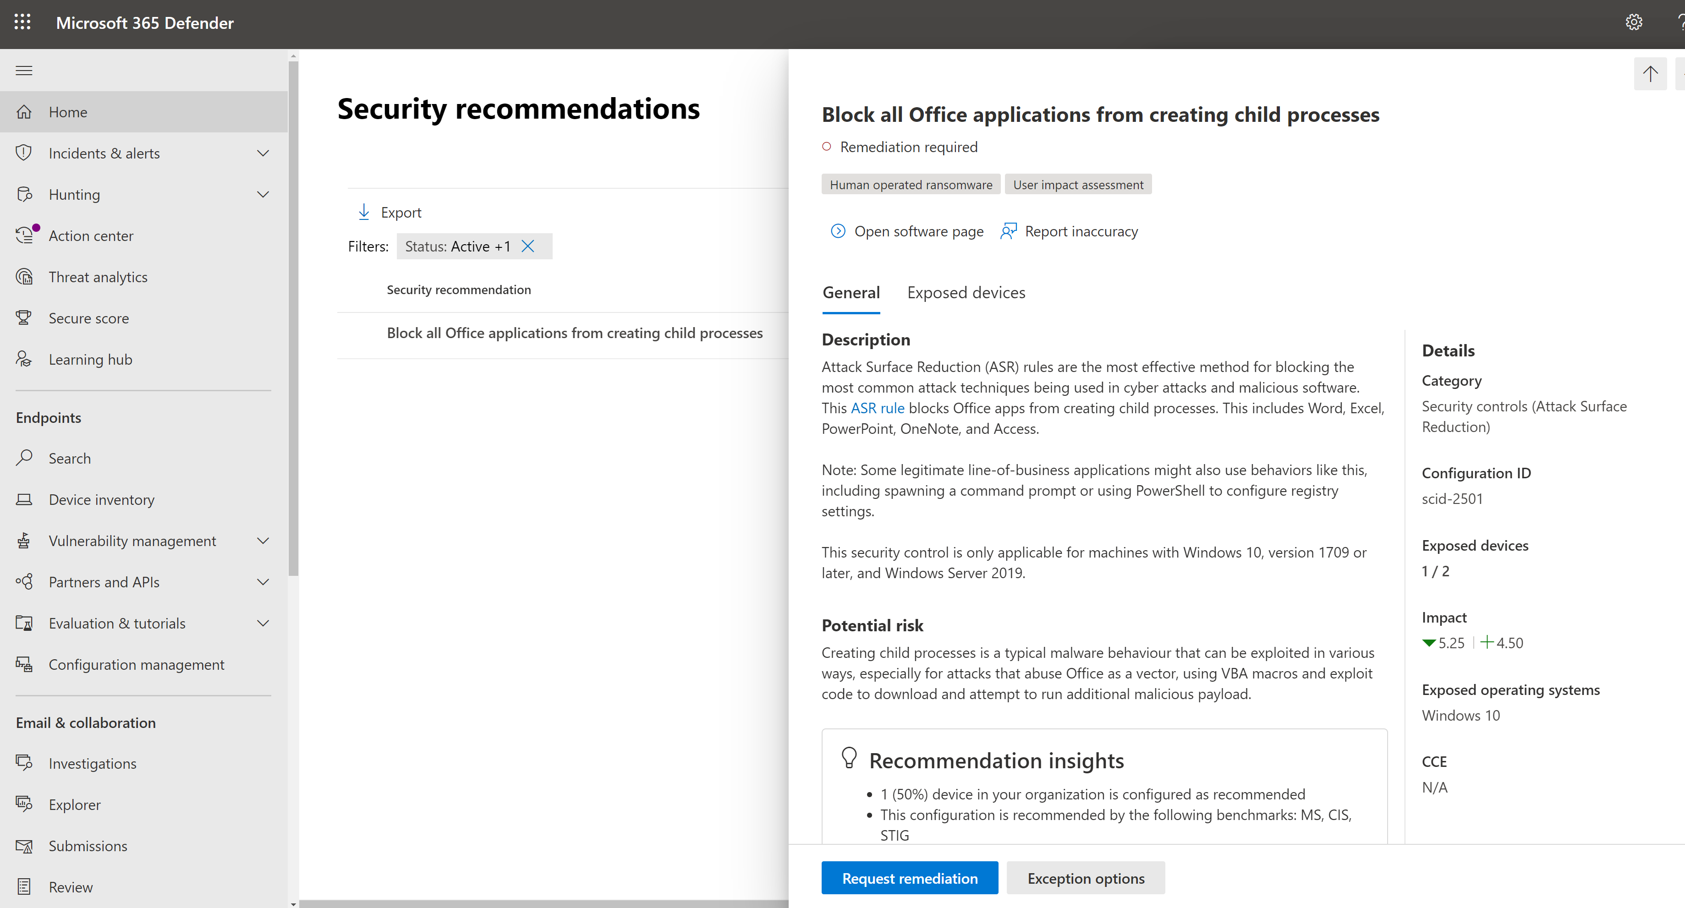

# Raise Remediation Requests

The Threat and Vulnerability Management capability in Microsoft Defender for Endpoint bridges the gap between Security and IT administrators through the remediation request workflow. Security admins can request for the IT Administrator to remediate a vulnerability from the **Security recommendation** pages to Intune.

1. **Request remediation via Remediation Tasks**

Within the security recommendations, Select **Request Remediation**

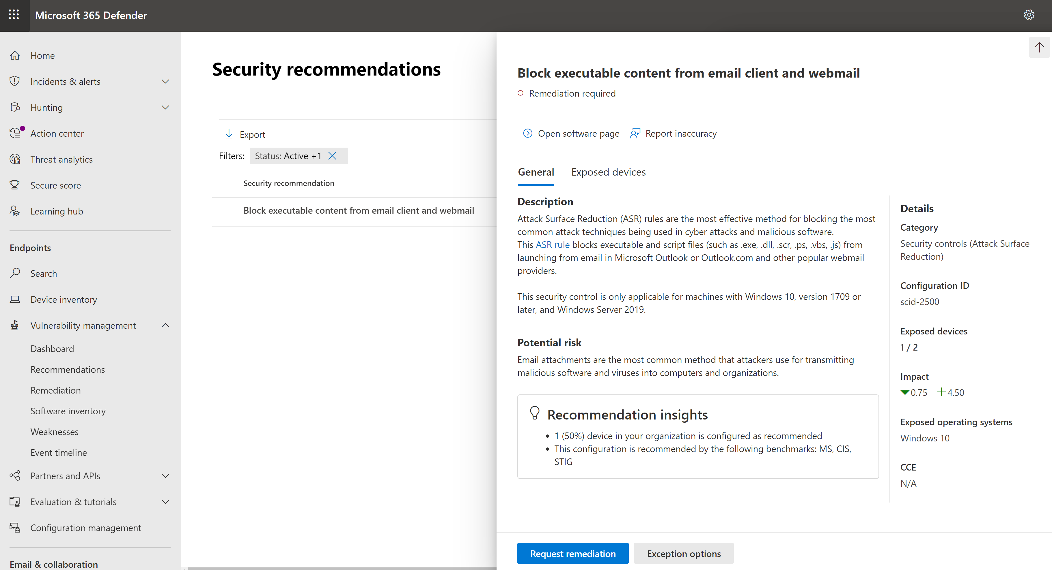

Review the remediation options and select **Next**

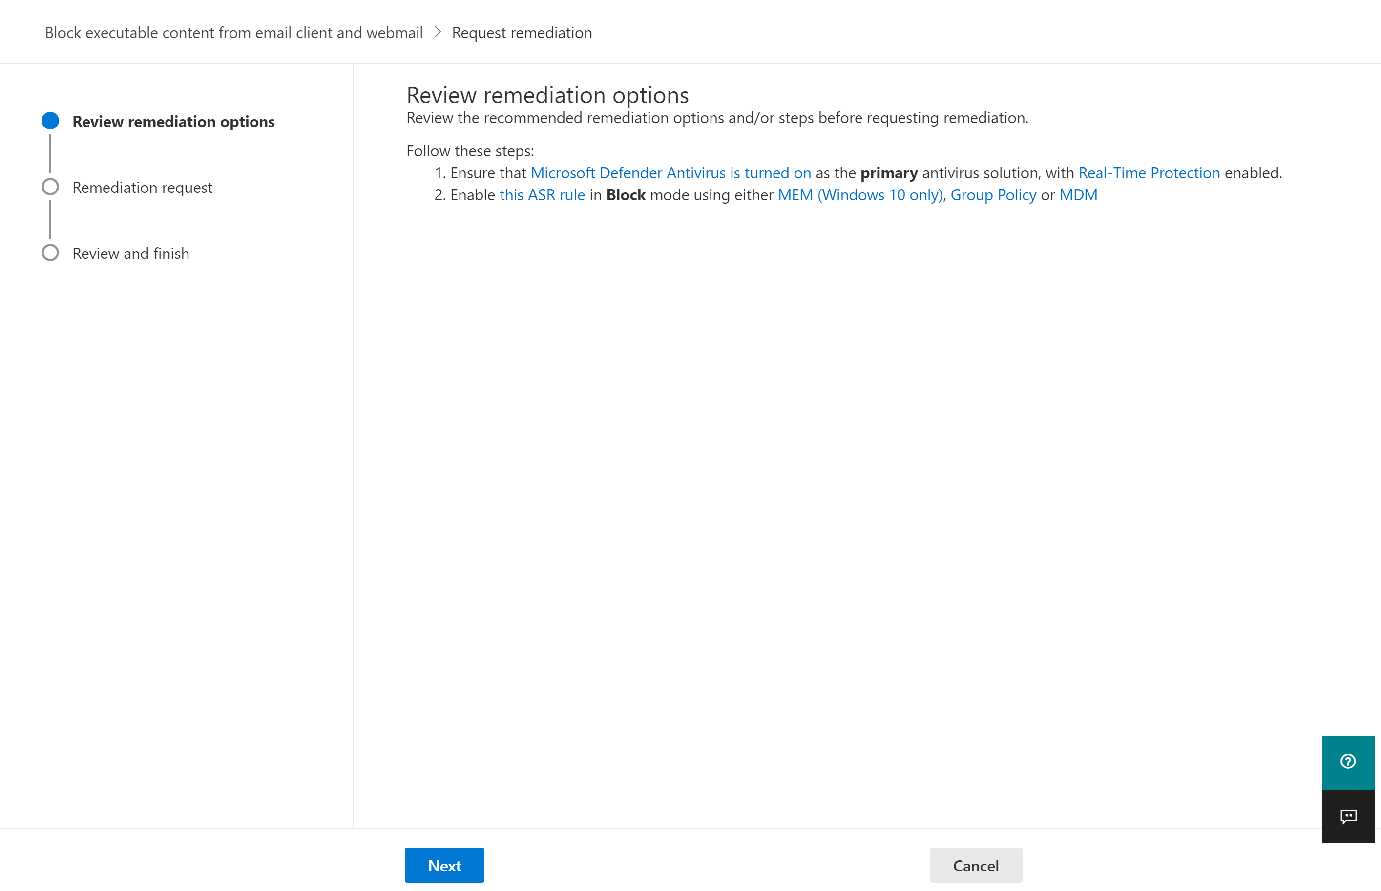

Select ‘**Open a ticket in Microsoft Endpoint Manager (for AAD joined devices)**’, provide a due date, priority and note description, then select **Next**

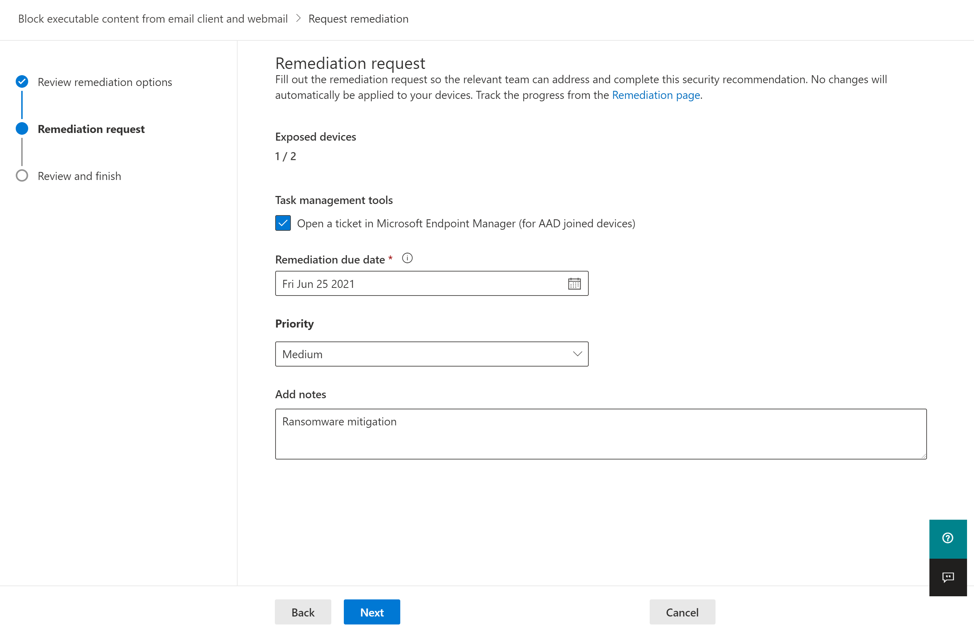

Review the remediation request summary, then select **Submit**:

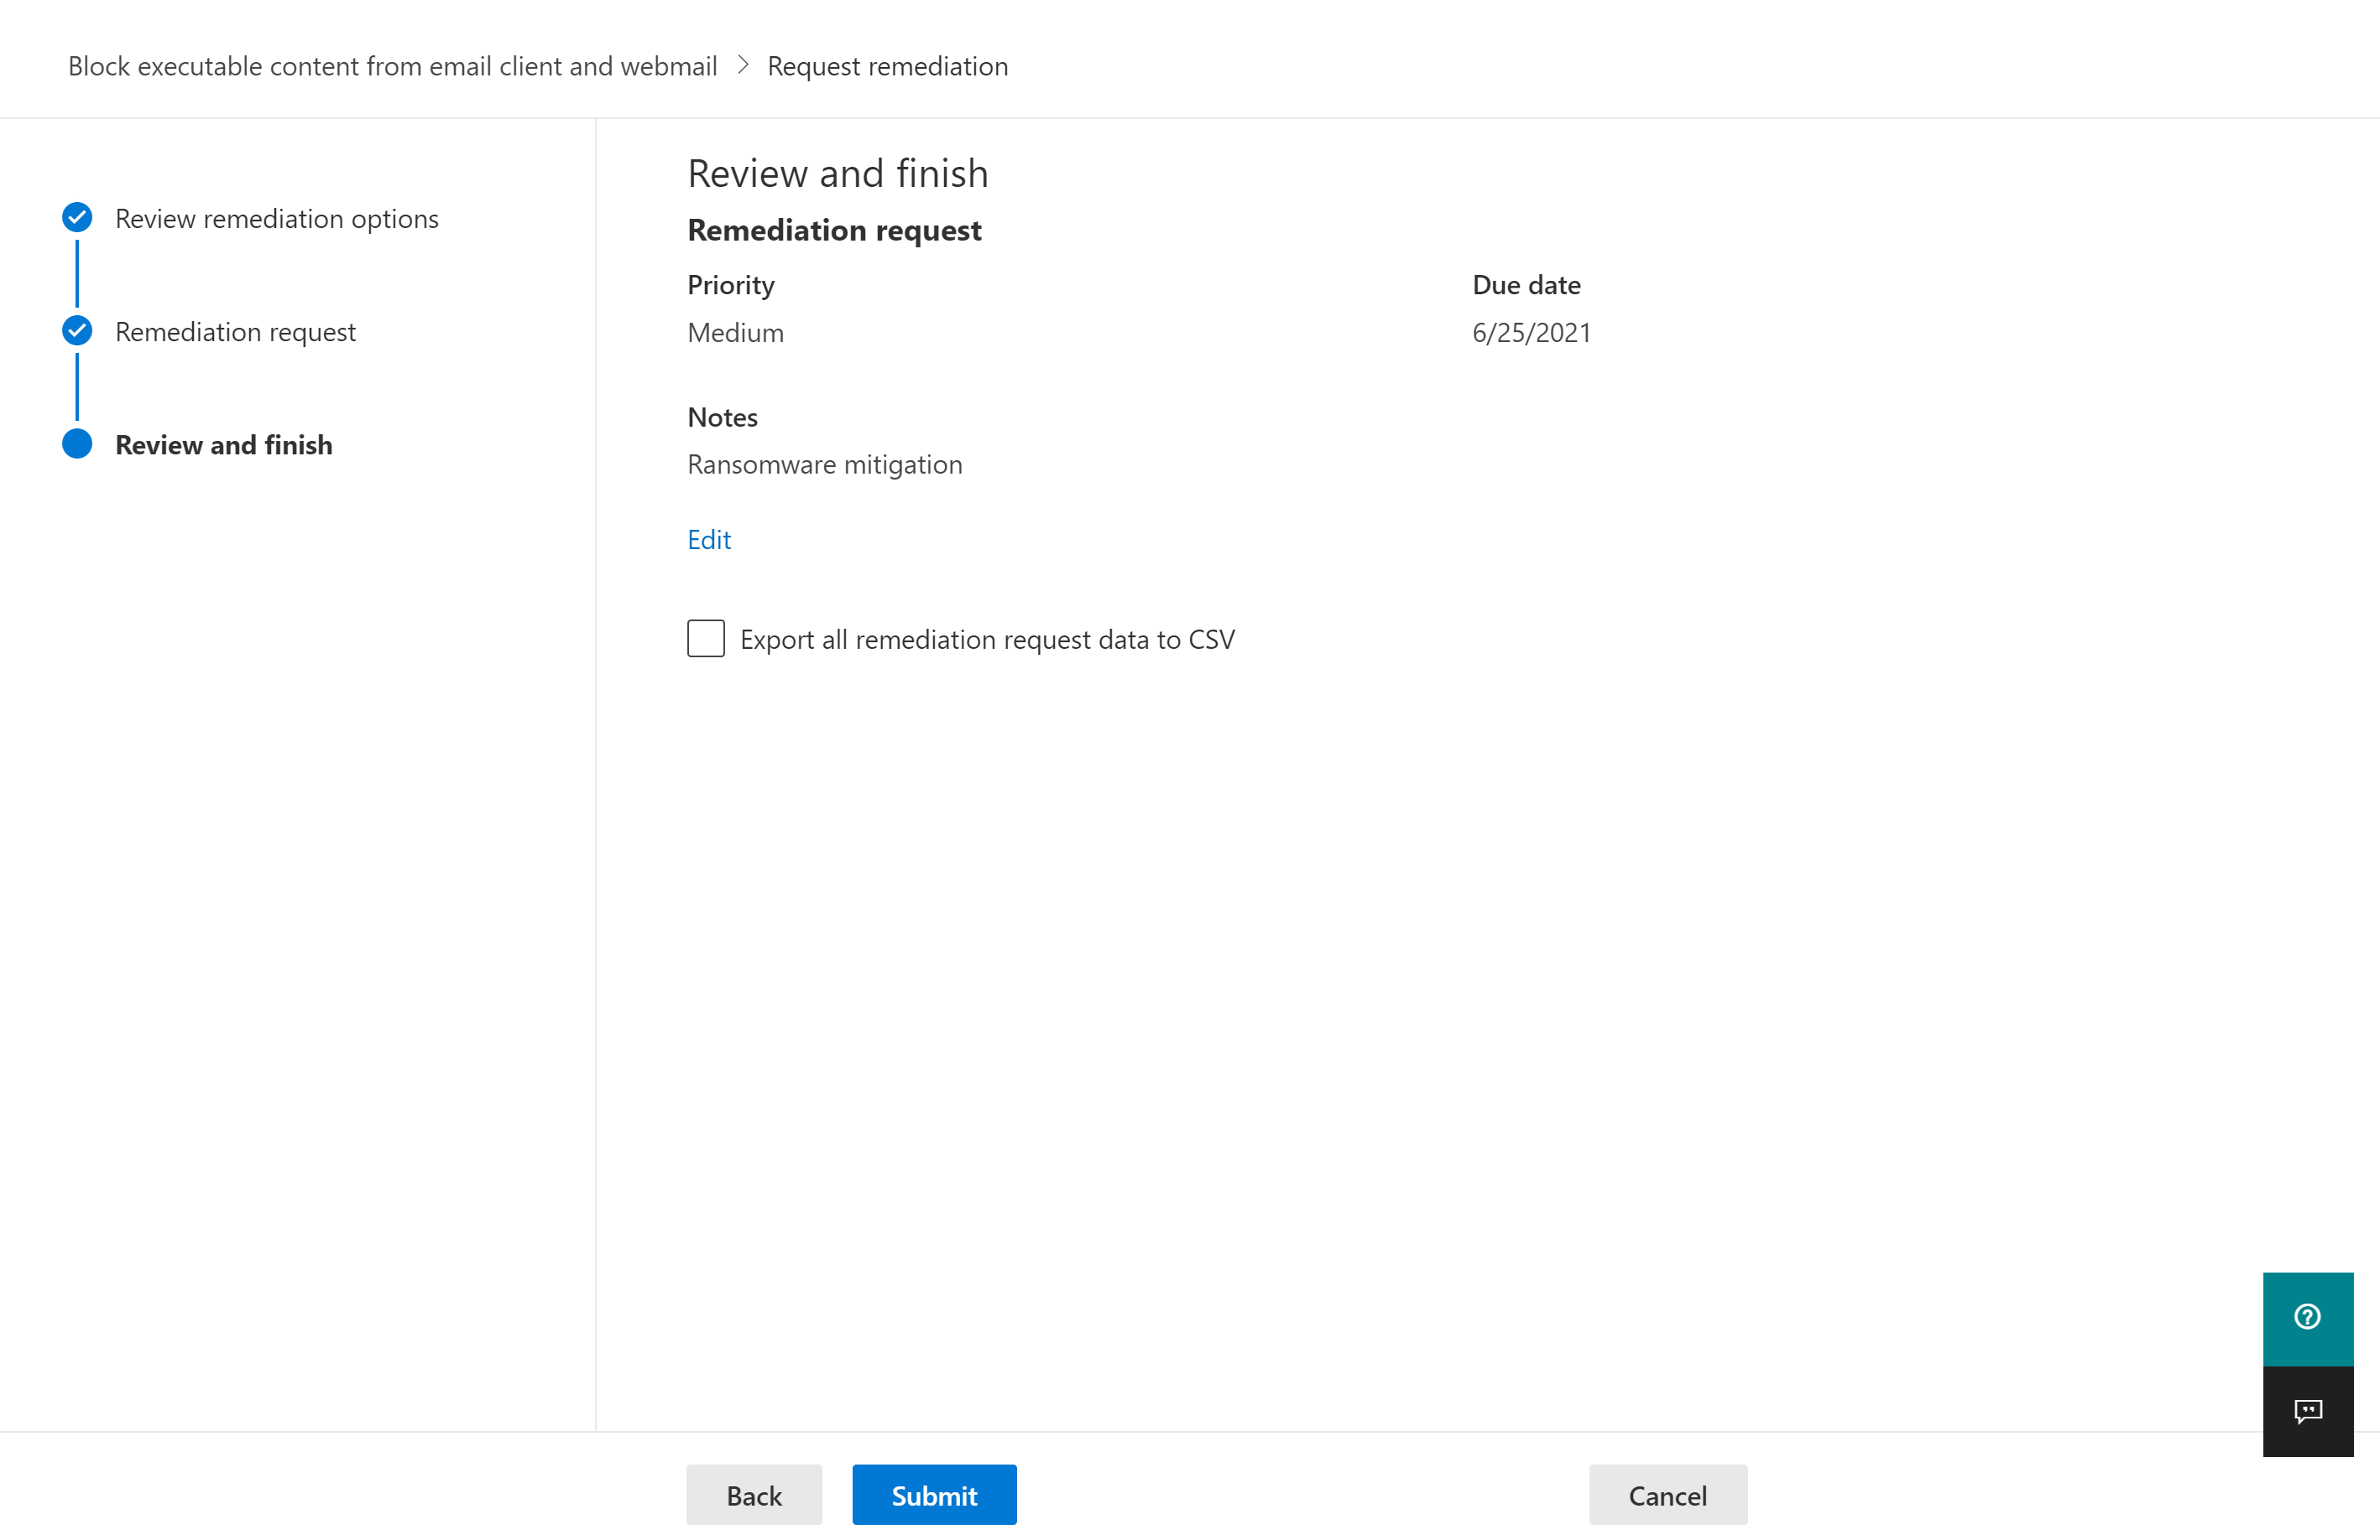

1. **View the Remediation Task**

View and monitor the progress of a remediation task via navigating to Vulnerability Management > Remediation:

NOTE: Remediation tasks can also be viewed within the Microsoft Endpoint Security console.

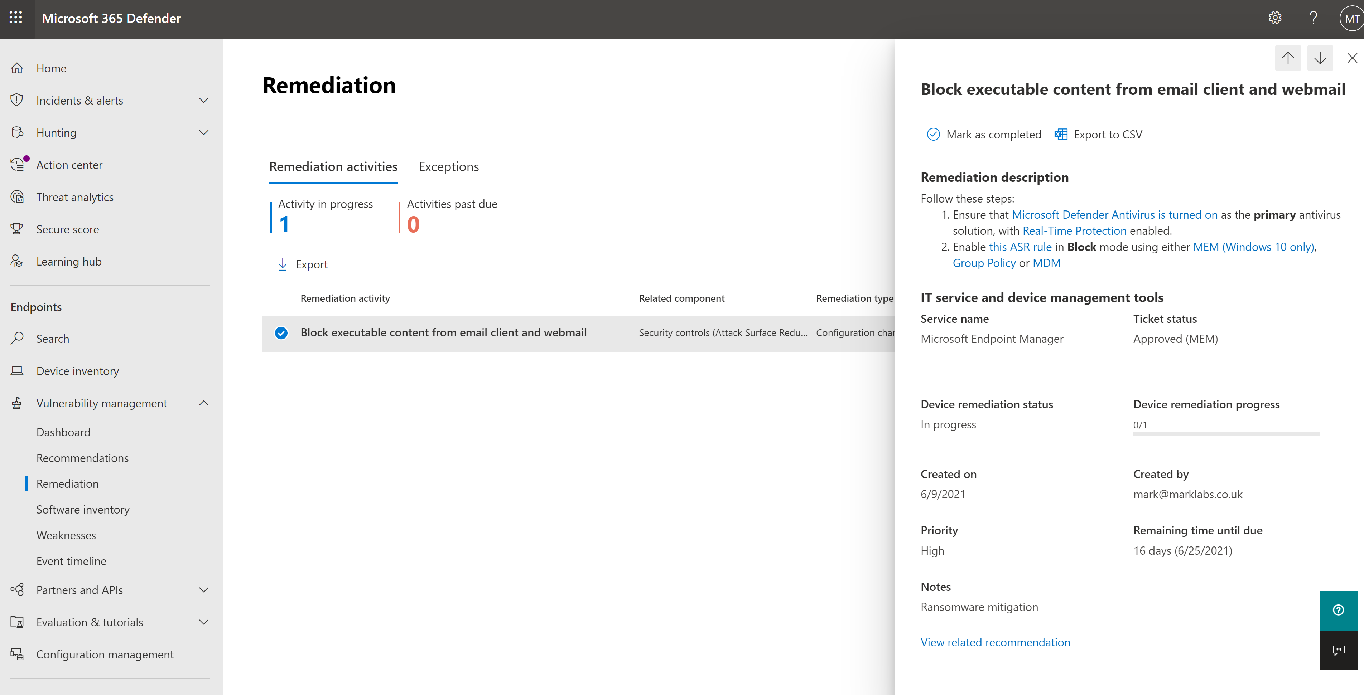

# Attack Surface Reduction Rules (MEM)

To configure Attack Surface Reduction rules as part of this lab we will use Microsoft Endpoint Manager > Endpoint Security.

**NOTE: If you do not have devices enrolled into Microsoft Endpoint Manager/Intune please see section 4 Attack Surface Reduction Rules (PowerShell) to apply an ASR configuration locally to a device**

1. **Access Microsoft Endpoint Manager admin center**

Navigate to: <https://endpoint.microsoft.com>

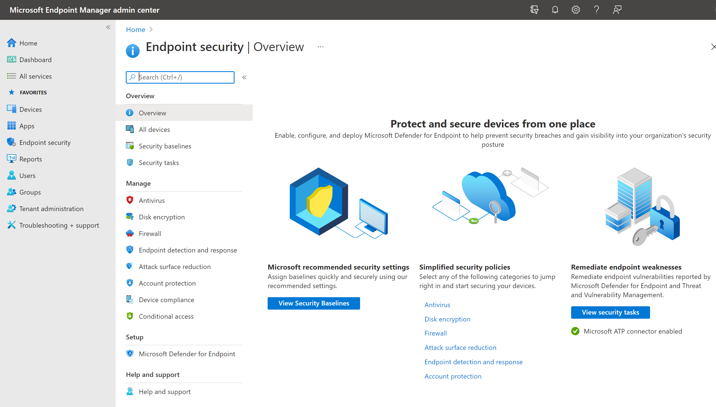

1. **Create an Attack Surface Reduction policy**

Navigate to Endpoint Security > Attack Surface Reduction then select **Create Policy**

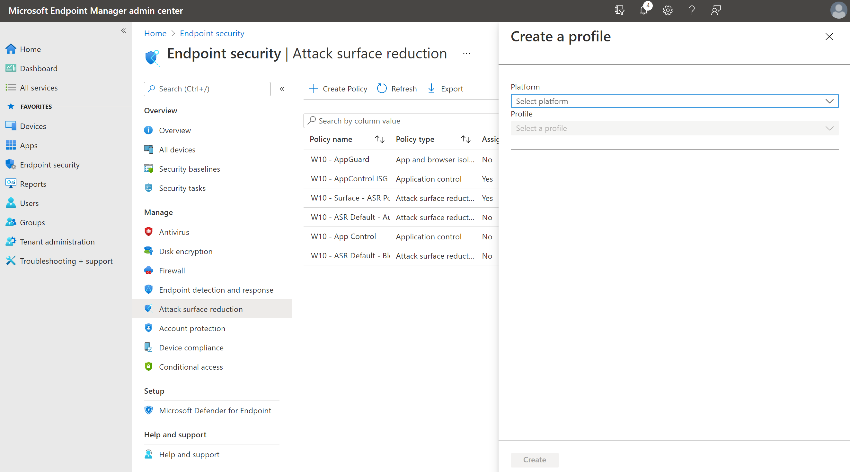

1. **Create an Attack Surface Reduction profile**

Select the following values: **Platform:** ‘Windows 10 and later’; **Profile:** ‘Attack Surface Reduction rules’ then select **Create**.

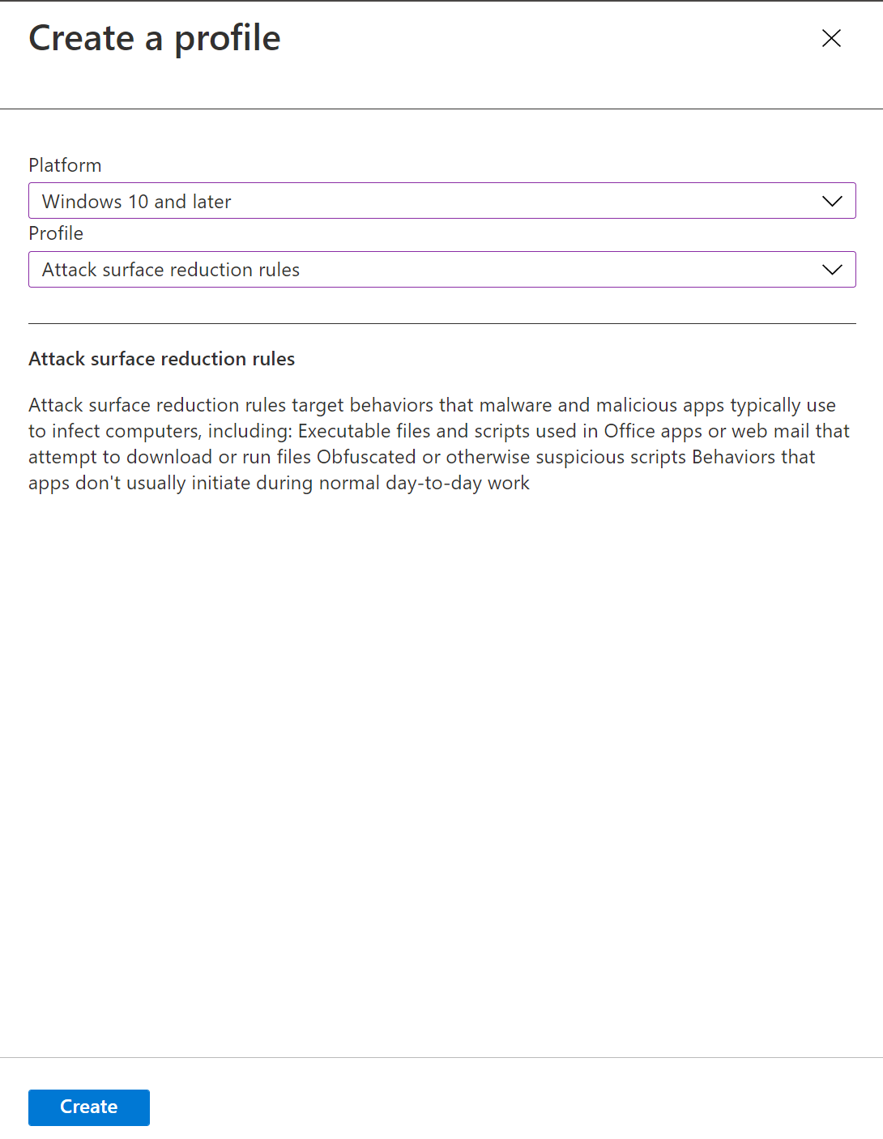

1. **Create an Attack Surface Reduction profile (cont)**

Provide a profile name and description, then select **Next**

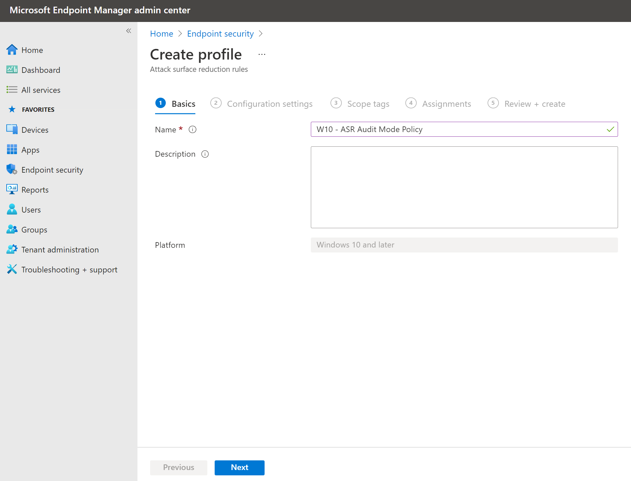

1. **Create an Attack Surface Reduction profile (cont)**

Review the rules and select Audit Mode for each rule, then select **Next**

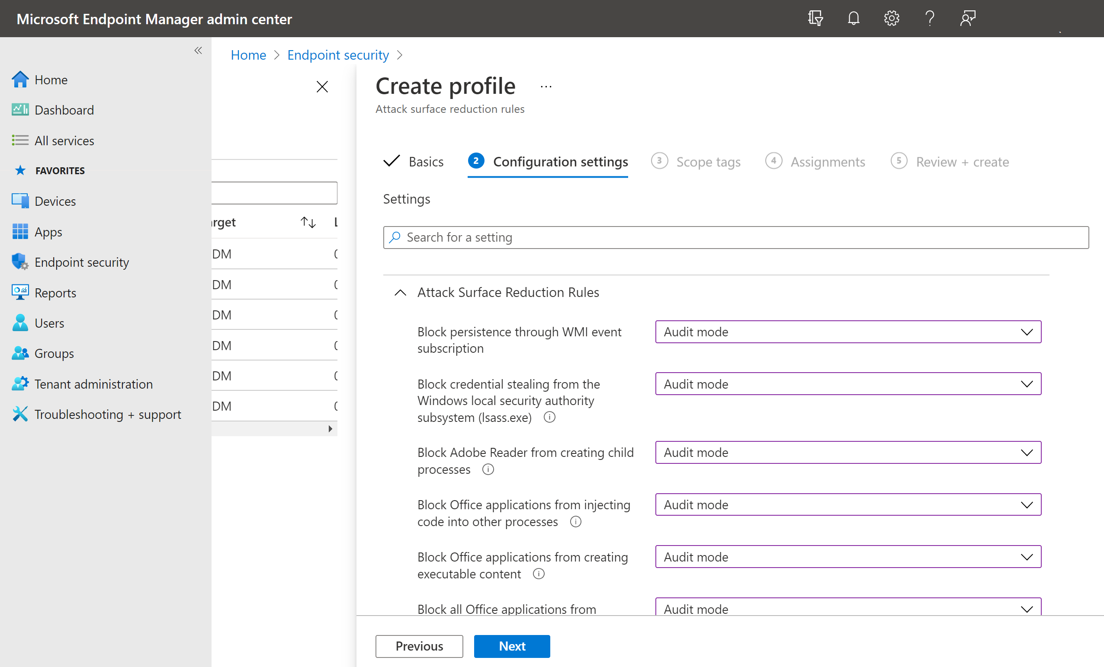

1. **Create an Attack Surface Reduction profile (cont)**

Review the rules and select Audit Mode for each rule, then select **Next**



1. **Create an Attack Surface Reduction profile (cont)**

On the scope tags page, select **Next**

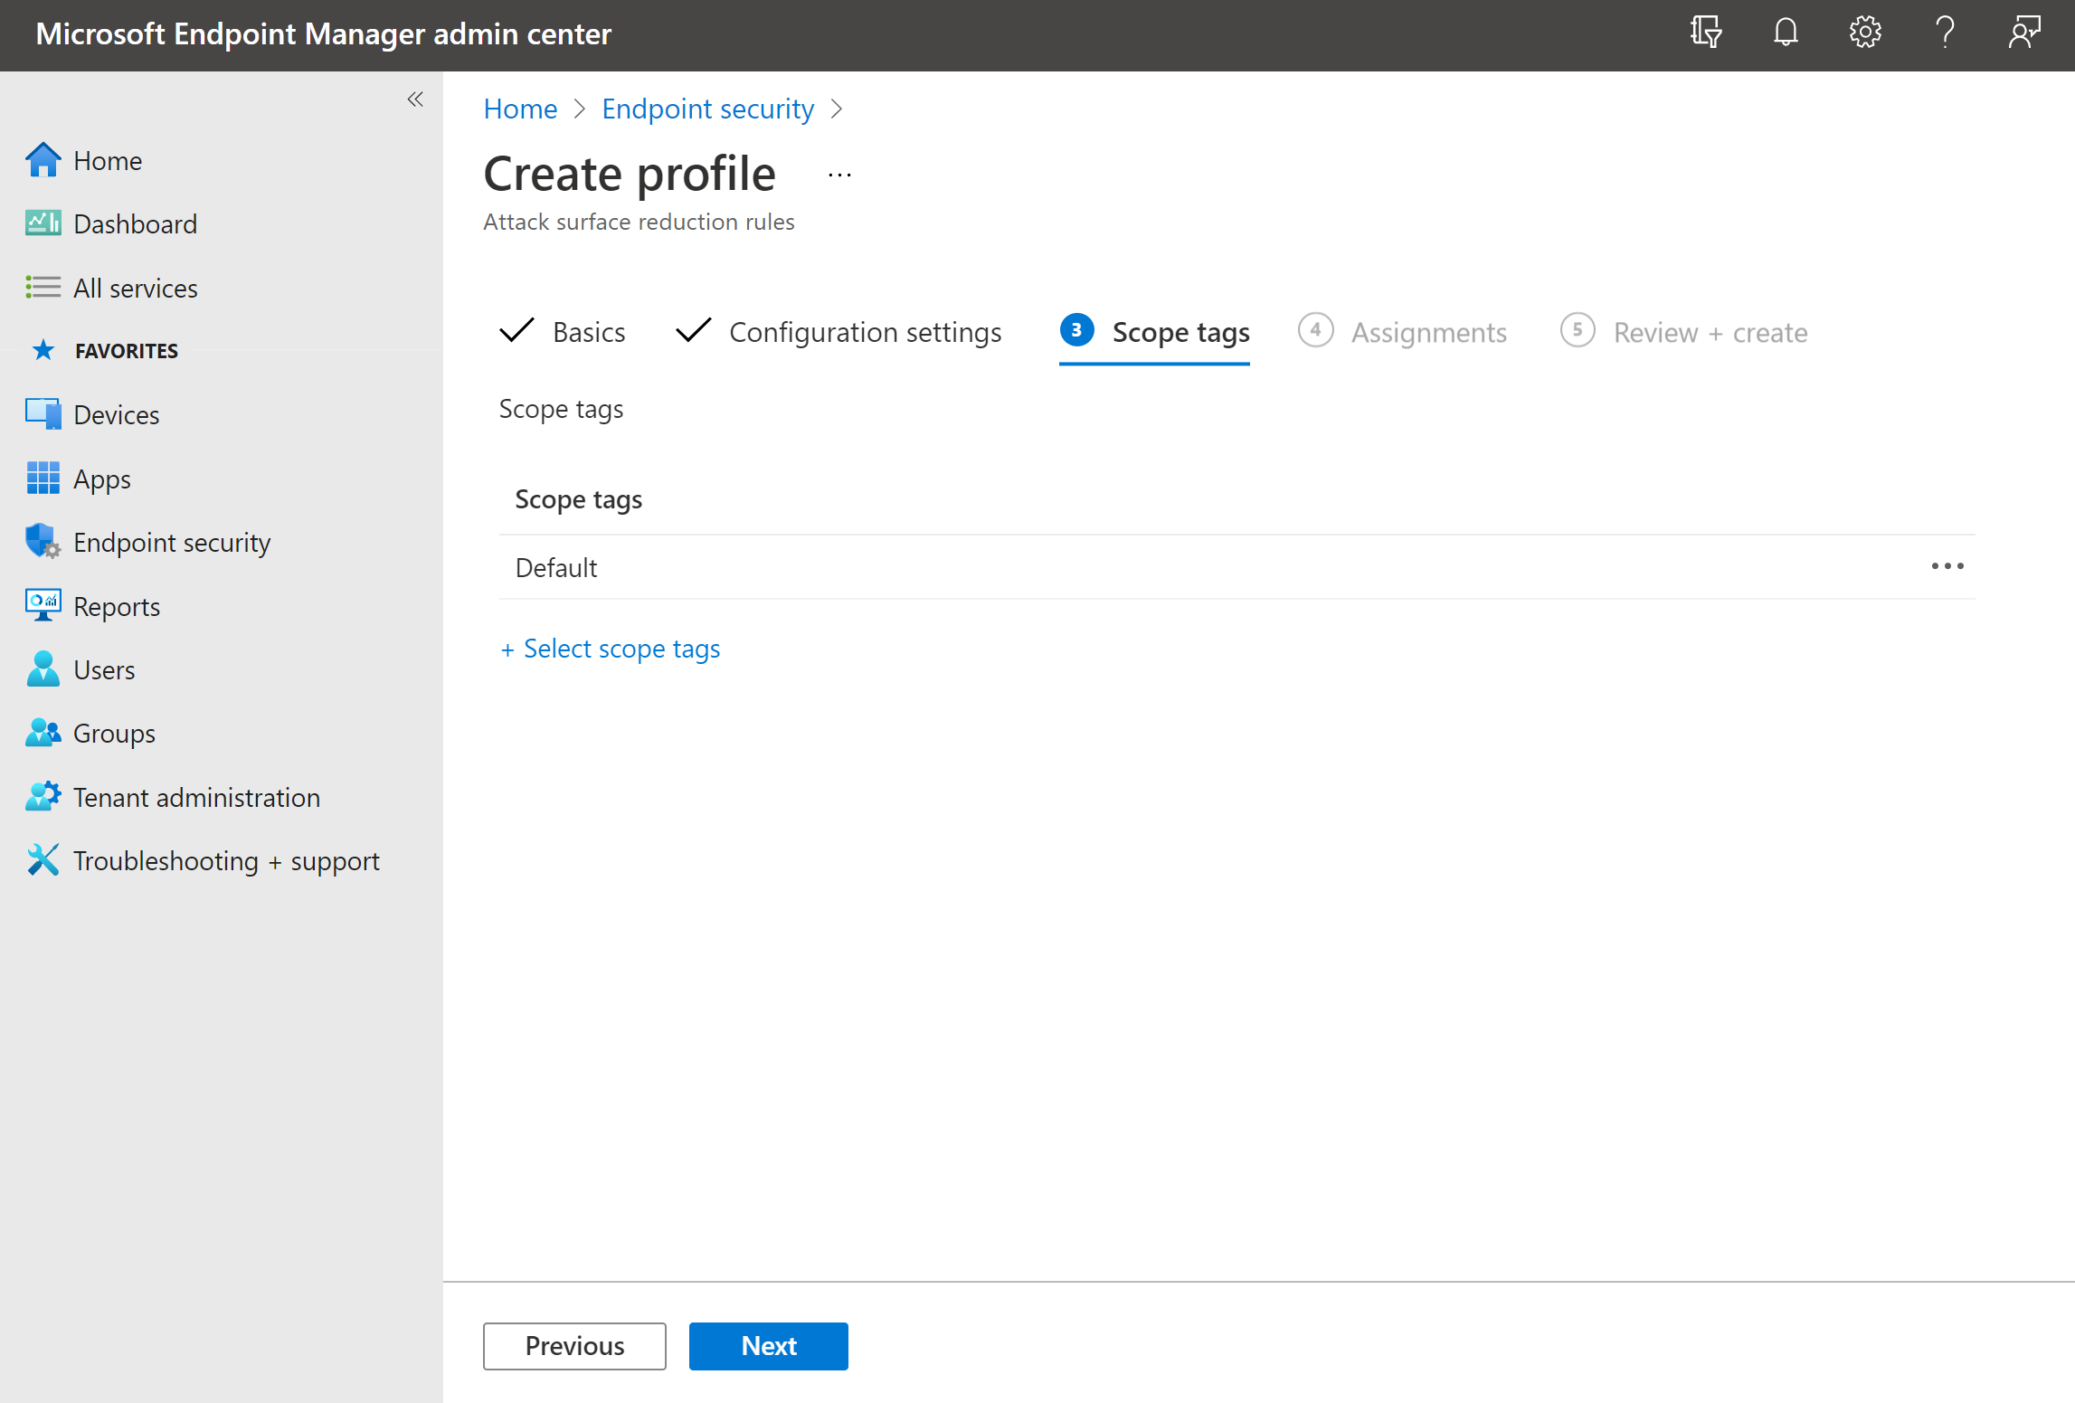

1. **Create an Attack Surface Reduction profile (cont)**

Within Included groups, add a device group to target the policy to, then select **Next**

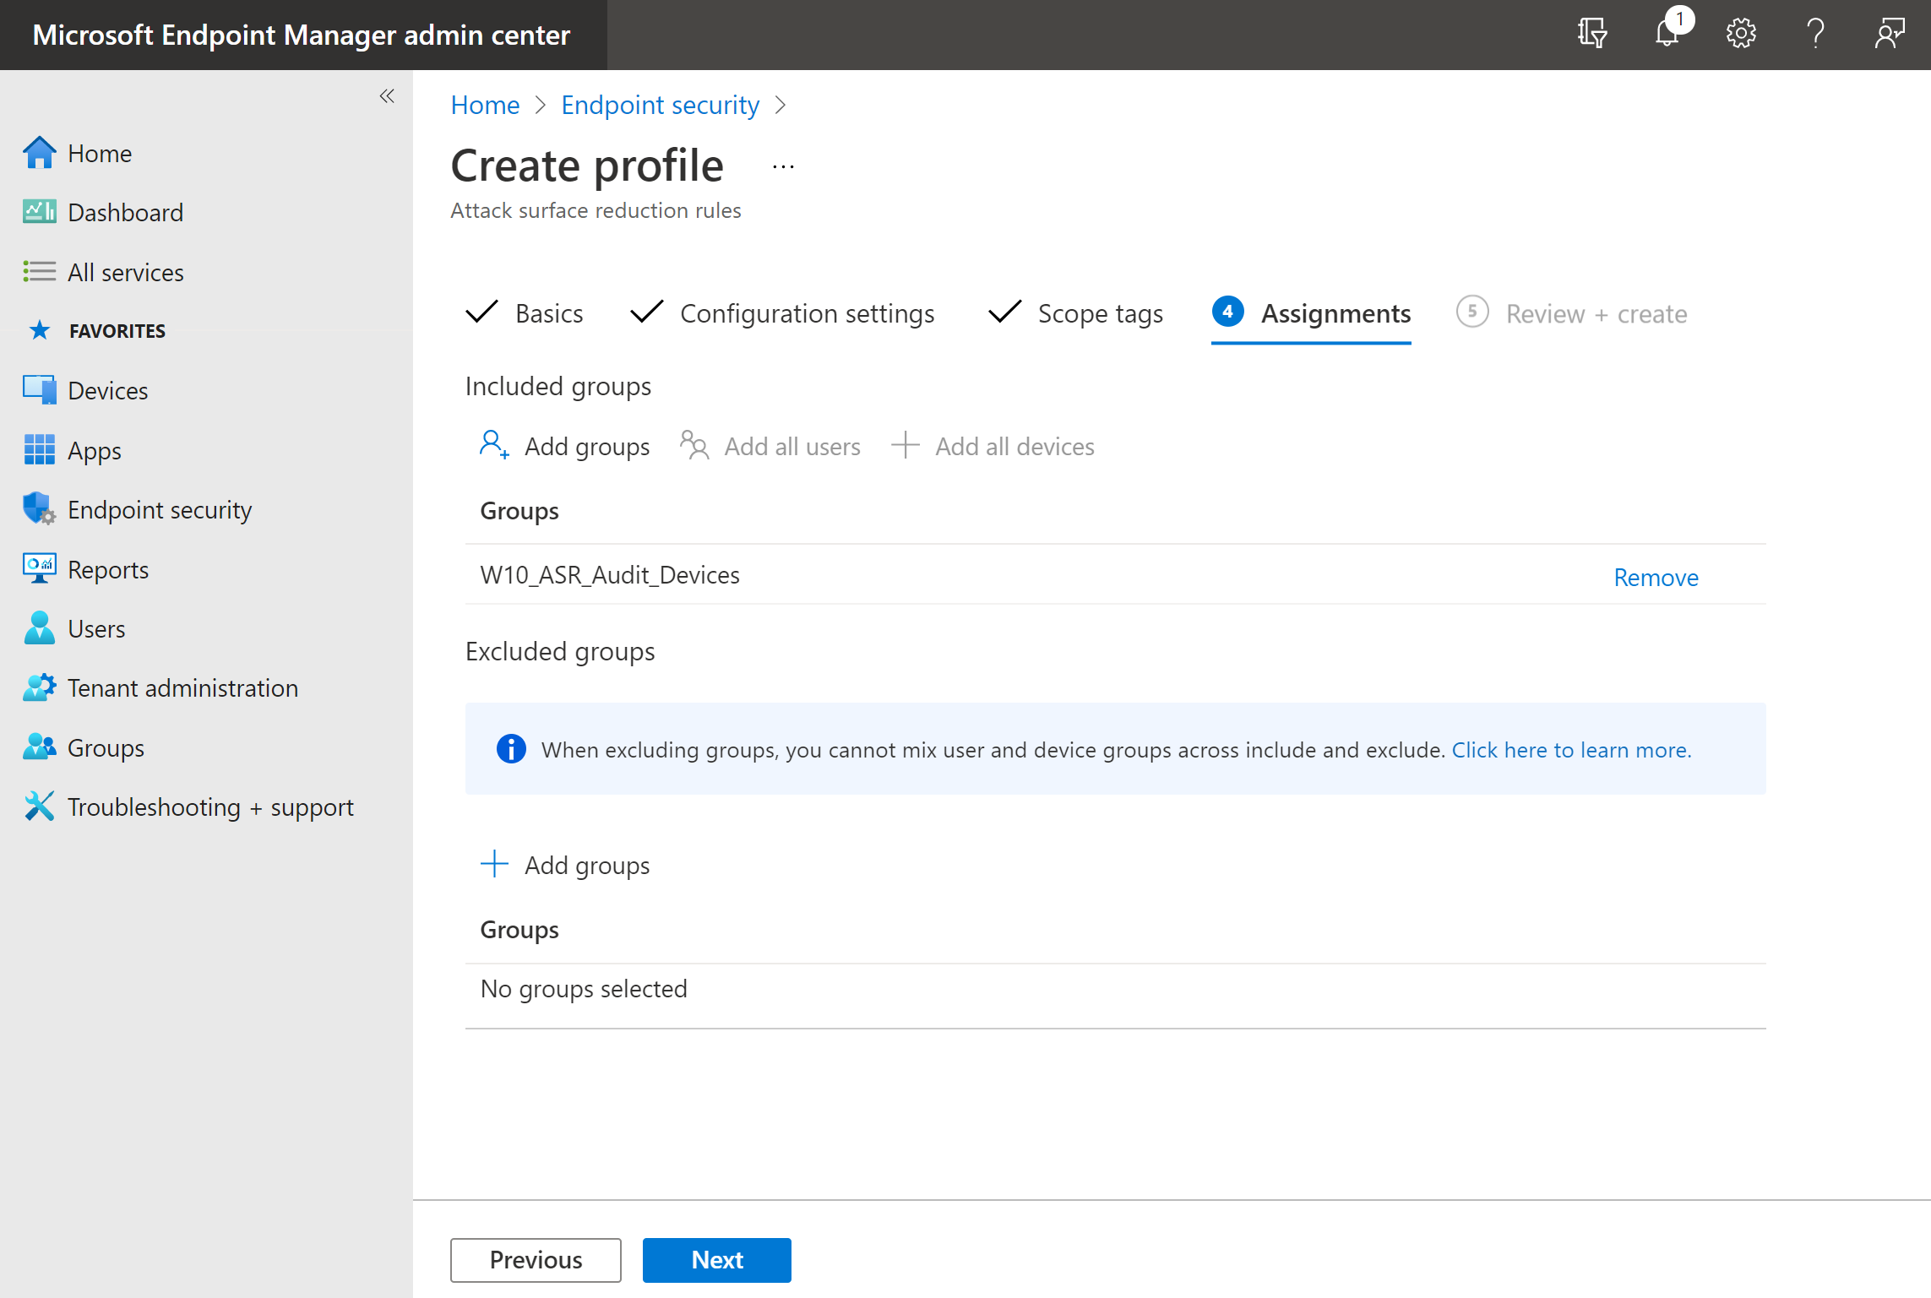

1. **Create an Attack Surface Reduction profile (cont)**

Review the policy, then select **Next**

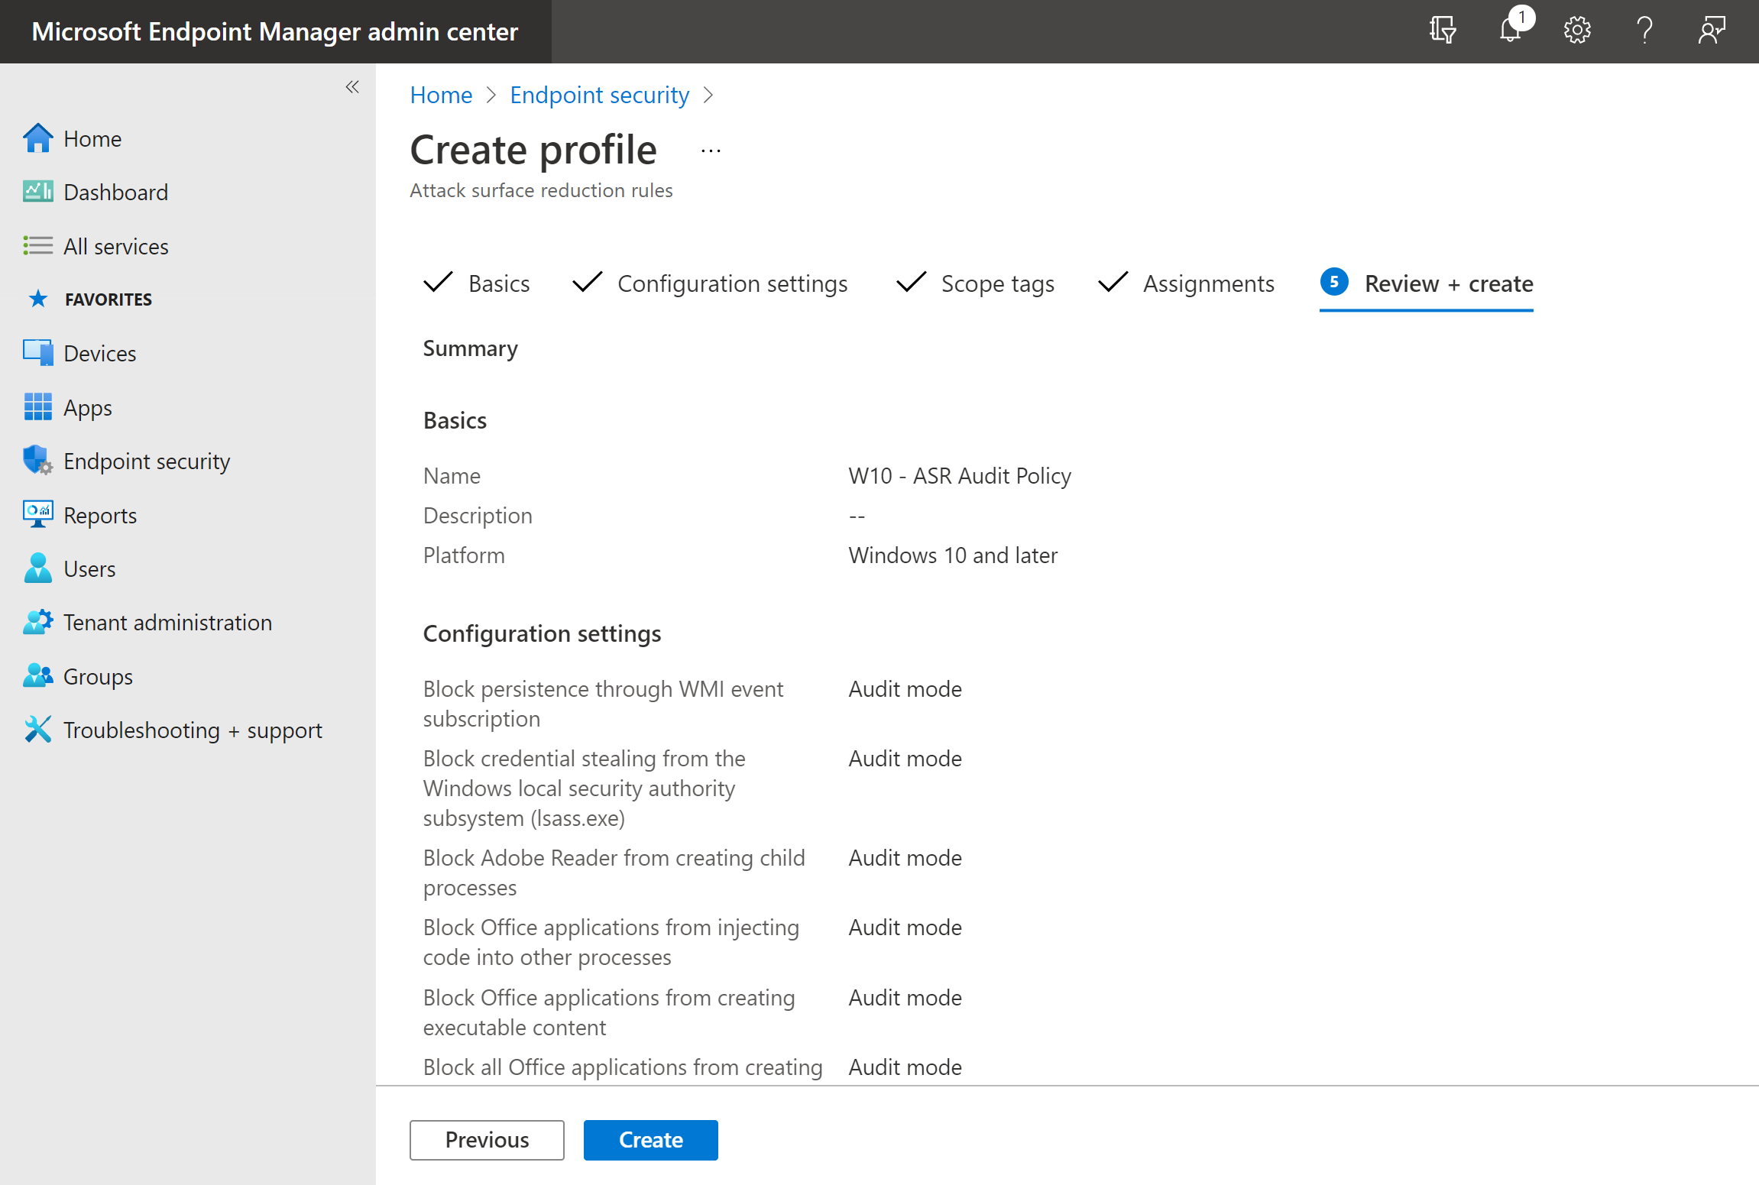

1. **Create an Attack Surface Reduction profile (cont)**

An Attack Surface Reduction rule policy has now been configured and assigned to a group of devices.

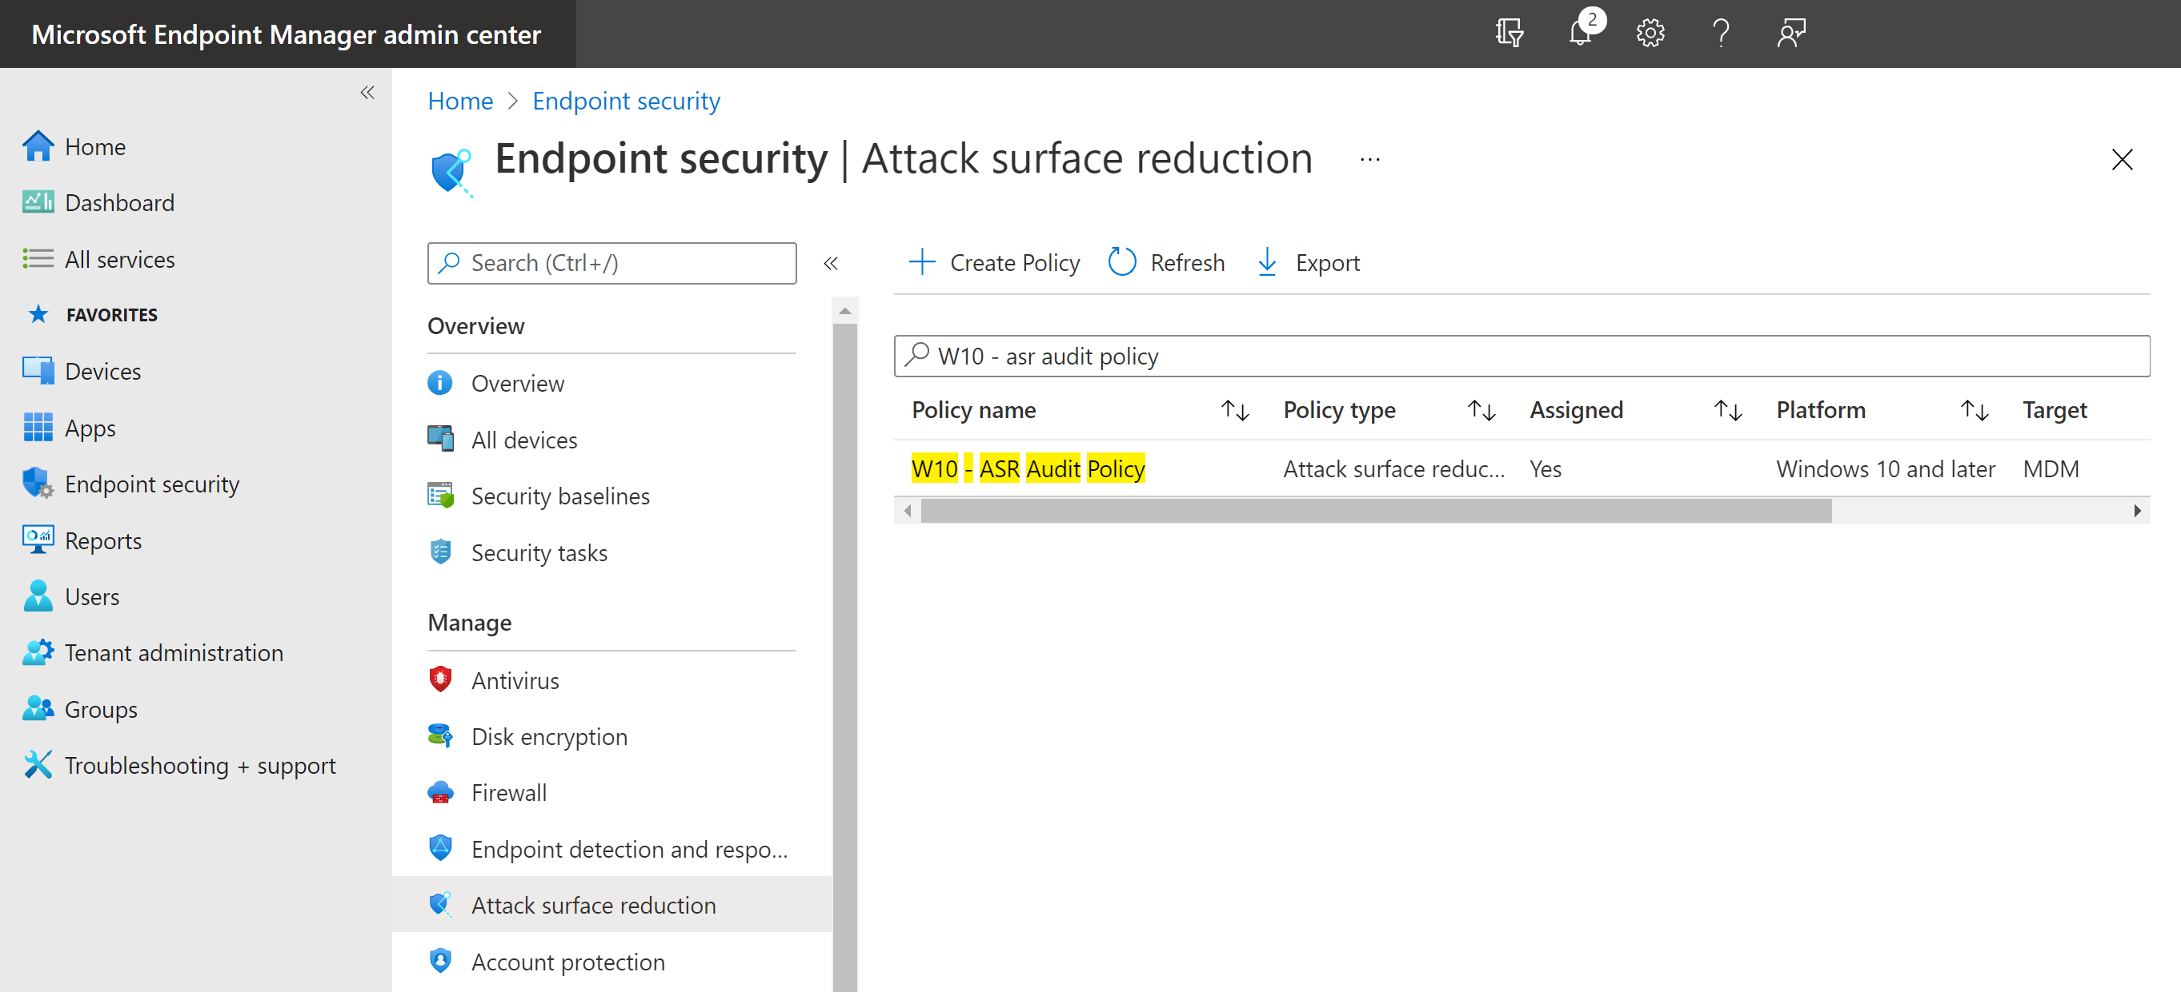

# Attack Surface Reduction Rules (PowerShell)

If you do not have devices onboarded via Microsoft Endpoint Manager, you can follow these steps to configure ASR rules locally on a device using PowerShell.

1. Download the ASR PowerShell scripts from: <https://demo.wd.microsoft.com/Content/WindowsDefender_ASR_scripts.zip>
2. Open an elevated PowerShell and run **WindowsDefender_ASR_Audit.ps1** to configure the rules in Audit mode. Check the script ran successfully as shown in the screenshot:

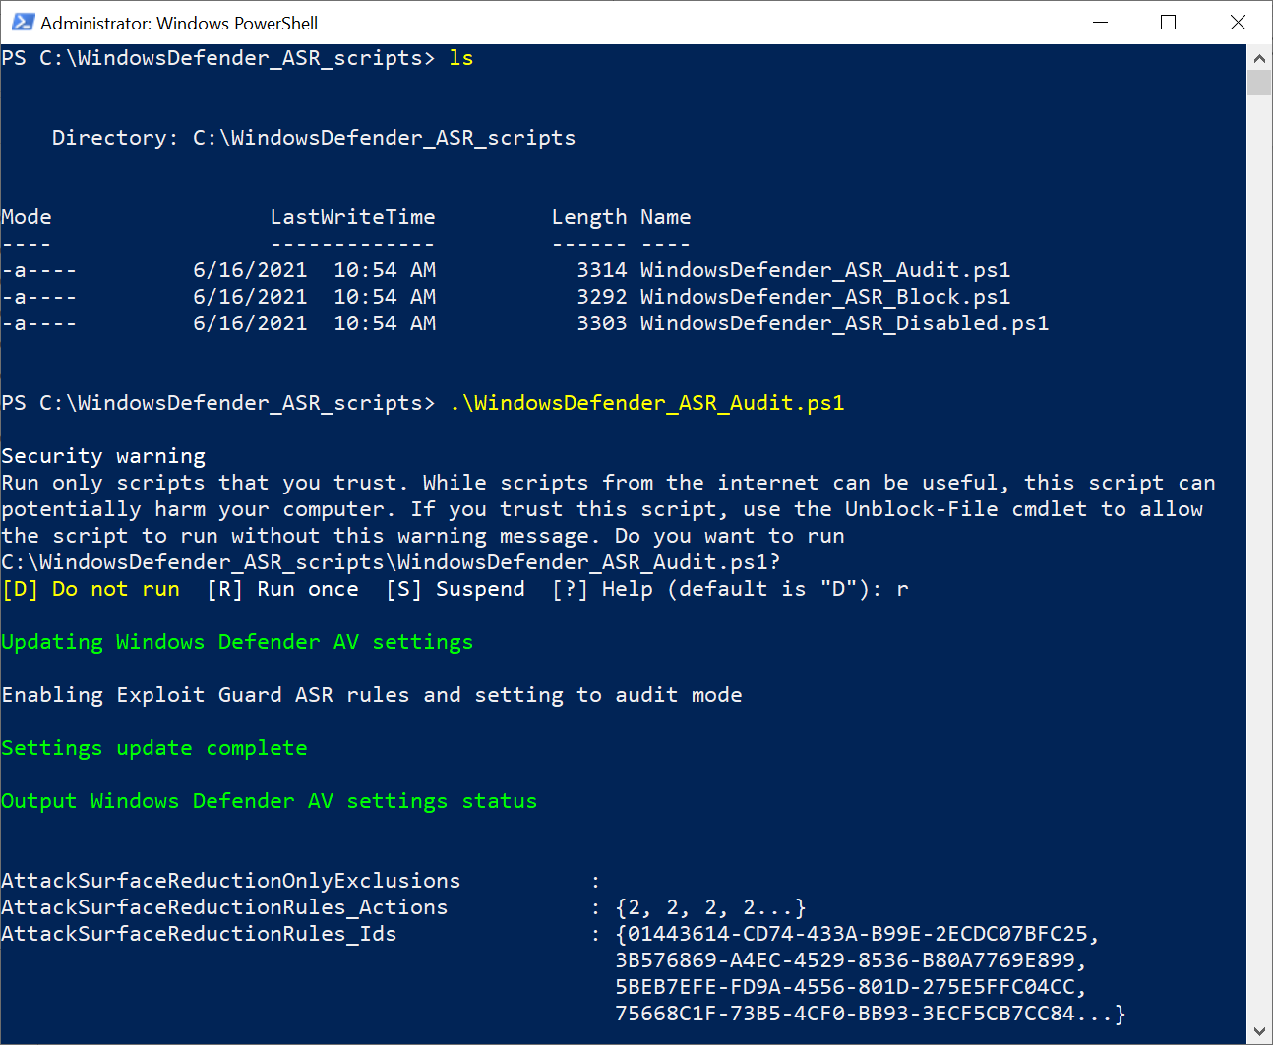

# Create Attack Surface Reduction Sample Data

Follow these steps to create sample ASR data and events on a device. To see the ASR related events in Microsoft Defender for Endpoint the device must be onboarded into Microsoft Defender for Endpoint.

**NOTE:** if you are using the supplied demo lab (MSDx734648.onmicrosoft.com) the ASR test files have been executed and the sample ASR data will be present in the Microsoft 365 Defender portal.

**NOTE:** Microsoft Office is required to run some of the ASR test files.

1. To test ASR rules, download the test ASR files from: <https://demo.wd.microsoft.com/Page/ASR>

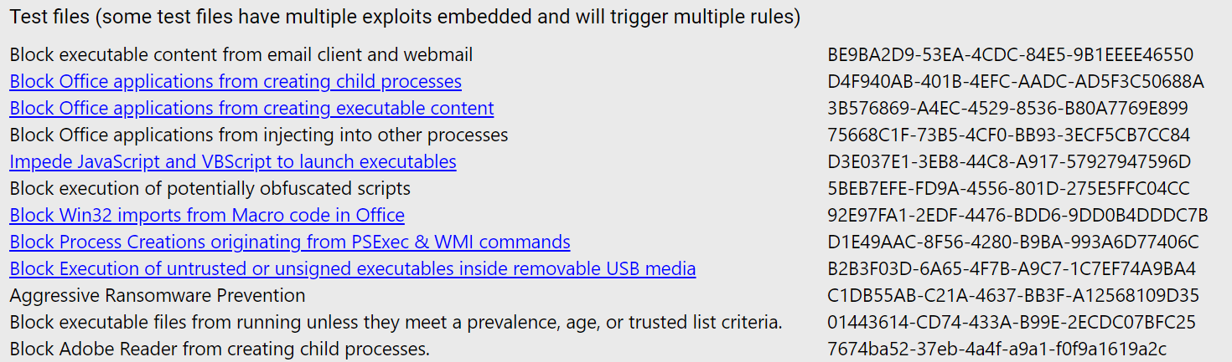

1. To create the sample ASR data run the downloaded files on a test device

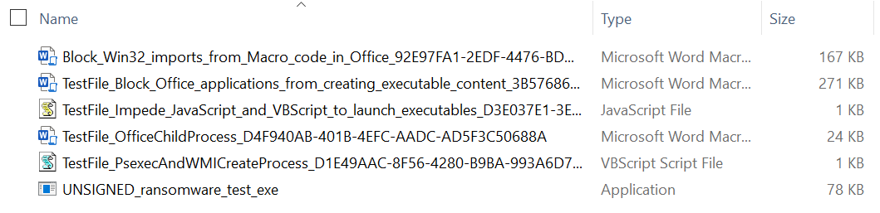

.

# Review Attack Surface Reduction Data

**NOTE:** if you are using the supplied demo lab (MSDx734648.onmicrosoft.com) the ASR test files will already have been executed and the sample ASR data will be present in the Microsoft 365 Defender portal.

### 6.1 View Attack Surface Reduction Rule Reports

You can worth with and view ASR rule data in various different ways:

Within the Microsoft 365 Defender portal, navigate to Reports > General > **Security Report**

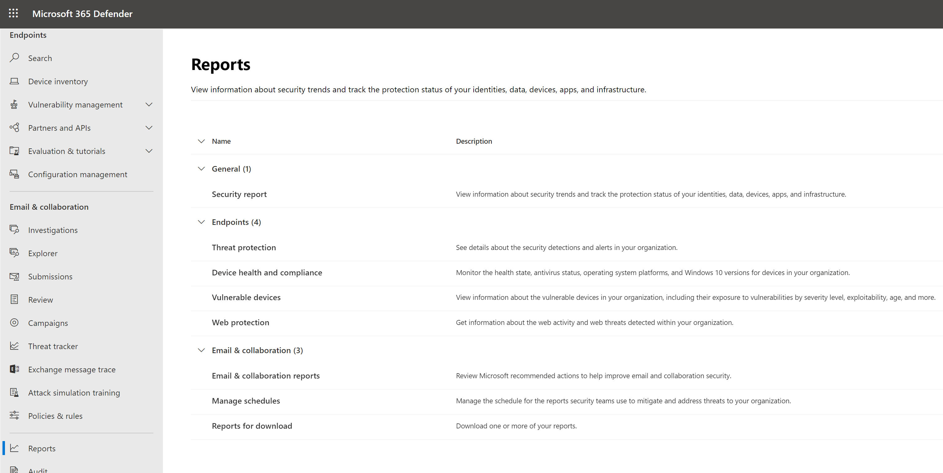

Navigate to the Attack Surface reduction rules reports and select **View detections**

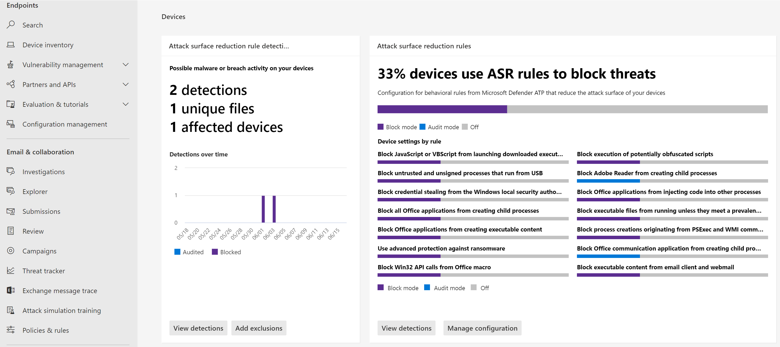

This report area helps you understand the ASR rule events which have been triggered, the configuration across devices and required exclusions.

Select Detections / Configurations / Add exclusions tabs to view the available data.

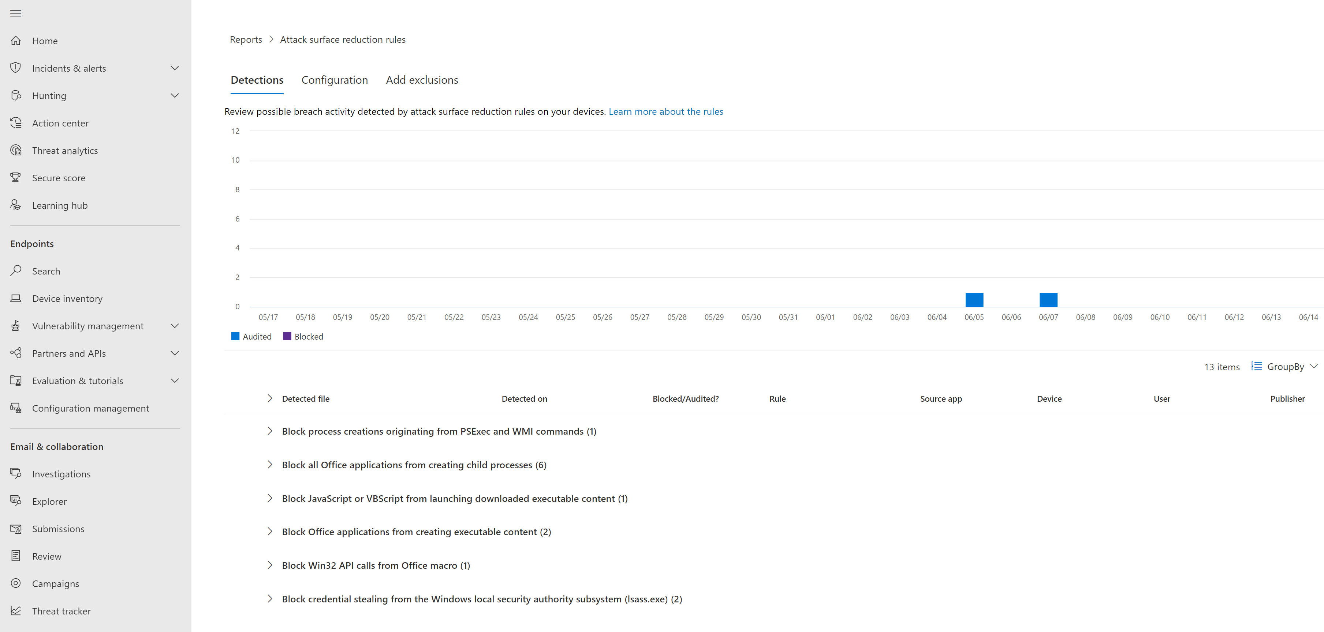

### 6.2 View Attack Surface Reduction Rules in TVM

Within the Microsoft 365 Defender Portal navigate to Vulnerability Management > **Recommendations**

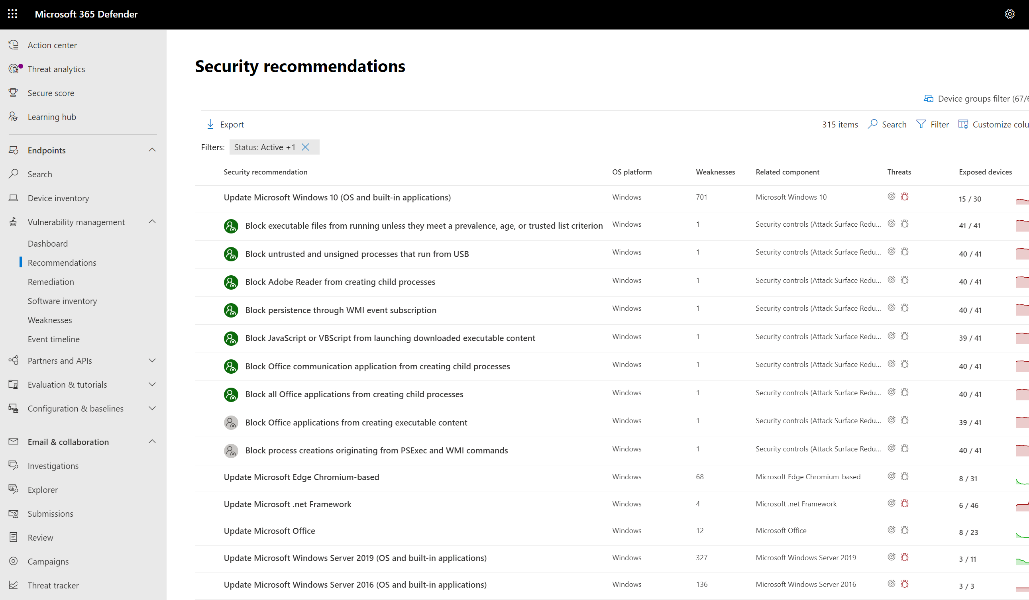

Within the Microsoft 365 Defender Portal navigate to Vulnerability Management > **Recommendations**



View the Attack Surface Reduction recommendations, note that **User impact** can be provided for some rules. This can help in configuring the rules in a Block mode.

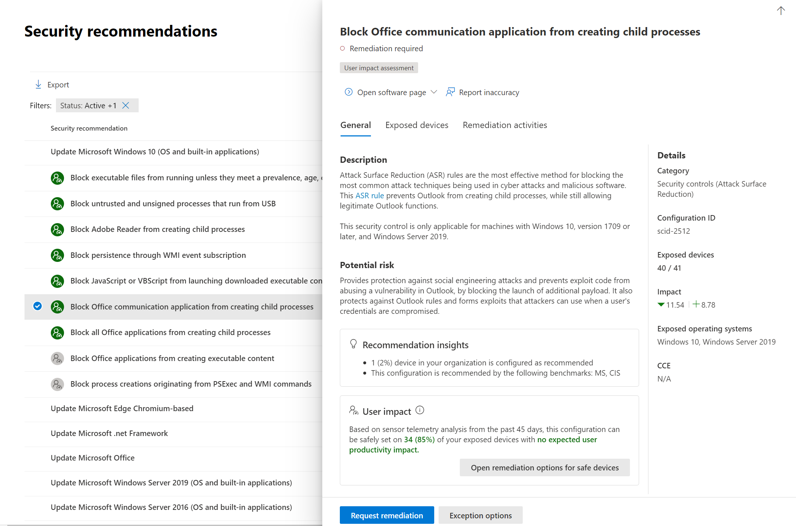

### 6.3 View Attack Surface Reduction Rules in Advanced Hunting

In this section we look at some simple queries to view the ASR rule event data.

Within the query editor run the following queries to see the ASR rule event data.

DeviceEvents

| where ActionType startswith "<<ASR_ACTION_TYPE>>"

Example:

DeviceEvents

| where ActionType startswith "AsrAdobeReaderChildProcess"

|  |  |
| --- | --- |
| **ASR_ACTION_TYPE:** | **ASR Rule** |
| AsrAdobeReaderChildProcess | Block Adobe Reader from creating child processes |
| AsrOfficeChildProcess | Block Office applications from creating child processes |
| AsrLsassCredentialTheft | Block credential stealing from the Windows local security authority subsystem |
| AsrExecutableEmailContent | Block executable content from email client and webmail |
| AsrUntrustedExecutable | Block executable files from running unless they meet a prevalence, age, or trusted list criterion |
| AsrObfuscatedScript | Block execution of potentially obfuscated scripts |
| AsrScriptExecutableDownload | Block JavaScript or VBScript from launching downloaded executable content |
| AsrExecutableOfficeContent | Block Office applications from creating executable content |
| AsrOfficeProcessInjection | Block Office applications from injecting code into other processes |
| AsrPersistenceThroughWmi | Block persistence through WMI event subscription |
| AsrPsexecWmiChildProcess | Block process creations originating from PSExec and WMI commands: |
| AsrUntrustedUsbProcess | Block untrusted and unsigned processes that run from USB: |
| AsrOfficeMacroWin32ApiCalls | Block Win32 API calls from Office macro |
| AsrRansomware | Use advanced protection against ransomware: |

Within the Microsoft 365 Defender Portal navigate to Hunting > **Advanced Hunting**, then select **Query**

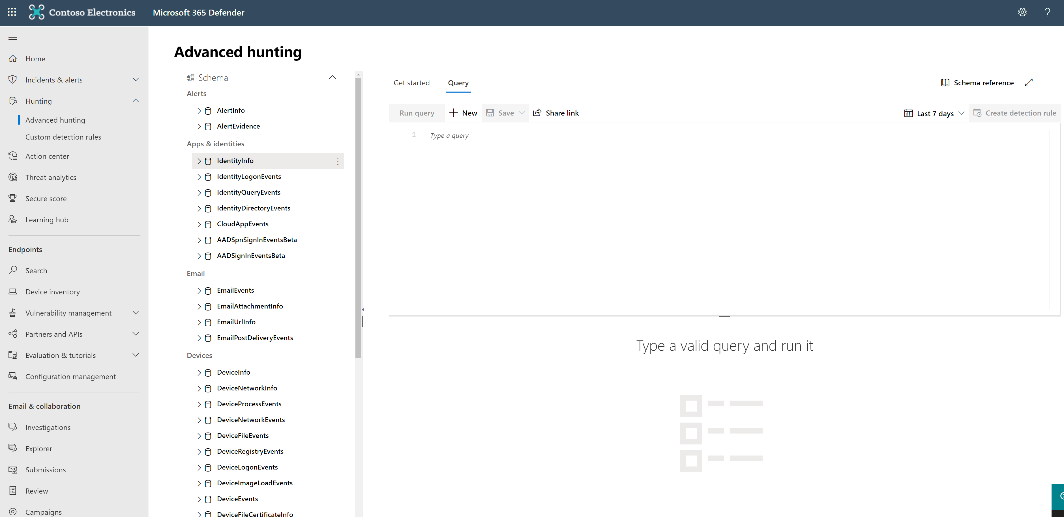

Summarise the ASR events seen over the last 30 days:

DeviceEvents

| where Timestamp > ago(30d)

| where ActionType startswith “Asr”

| summarize EventCount=count() by ActionType

You can also build out the queries to help focus on the required information. This can be powerful when understanding how to configure rules and exceptions.

Example:

DeviceEvents

| where ActionType startswith "AsrExecutableOfficeContent"

| project Timestamp, DeviceName, InitiatingProcessFileName, FolderPath, FileName, AdditionalFields

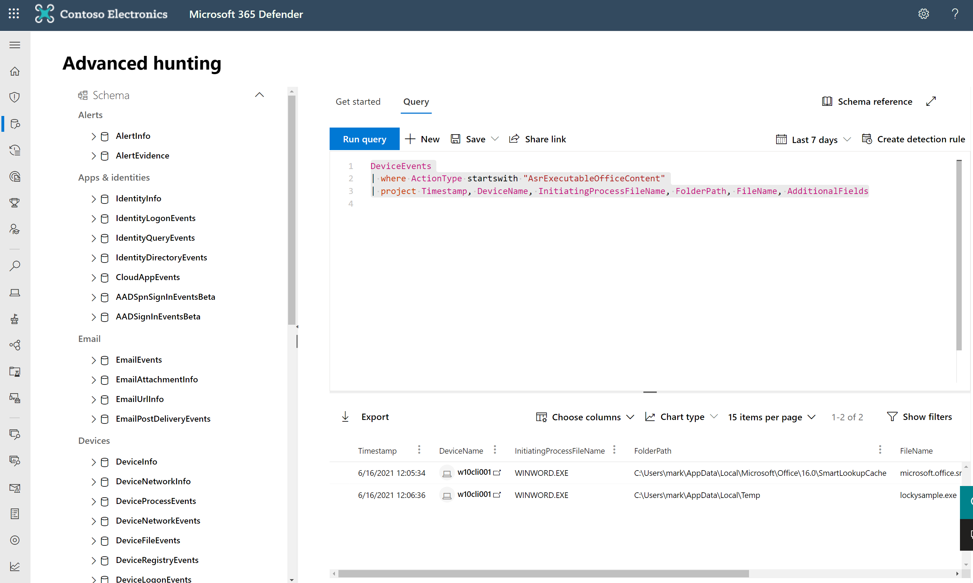

# Update ASR rule policies to block mode

Enabling ASR rules in Audit mode allows you to make a more informed decision about which rules you will effectively enable and configure in block mode.

To protect users and devices once the ASR rule data has been reviewed rules can be set into Block mode. Using the steps provided above as part of this lab the ASR rule configuration and data can be continually monitored whilst moving the rules into a block state.

# References

Track and respond to emerging threats with Microsoft Defender for Endpoint threat analytics | Microsoft Docs

<https://docs.microsoft.com/en-us/microsoft-365/security/defender-endpoint/threat-analytics>

Remediate vulnerabilities with threat and vulnerability management | Microsoft Docs

<https://docs.microsoft.com/en-us/microsoft-365/security/defender-endpoint/tvm-remediation?view=o365-worldwide>

Use attack surface reduction rules to prevent malware infection | Microsoft Docs <https://docs.microsoft.com/en-us/microsoft-365/security/defender-endpoint/attack-surface-reduction?view=o365-worldwide>

Demystifying attack surface reduction rules - Part 1 - Microsoft Tech Community <https://techcommunity.microsoft.com/t5/microsoft-defender-for-endpoint/demystifying-attack-surface-reduction-rules-part-1/ba-p/1306420>